**Northeastern University**

CS 6620 Cloud Computing

**Project #1** [200 points]

**EC2 Instances Creation and Operations**

# Guidelines

Project #1 should be electronically submitted to Canvas by midnight on the due date. A submission link is provided on Canvas.

# Assignment Overview

For this project, you will get familiar with the cretaion of multiple EC2 instances on AWS and conducting different operations on them, via programming as well as using the AWS cosnole. Part I requires programming. Part II is basic preparation via the cosnole, for the next project assignment (i. e., Project 2).

Please post any questions to Piazza and attend TA office hours to address any questions. Get started early.

**PART I: Basic EC2 Operations via Programming**

1. Using an appropriate method you need to set up an EC2 instance
2. Modify the EC2 instance initiated from #1 above by as signing a tag to the instance
3. Further modify Q1 to reboot the EC2 instance that you had set up at the beginning
4. When the entire process of set up has been completed then stop the EC2 instance.
5. Start 5 to 6 EC2 instances and assign tags randomly ensuring there are 2 different tags in total
6. Find all the instance id that are actively running and report the same
7. Filter the EC2 instance based on tags
8. Describe the properties of all the EC2 instances
9. Update the tag to make sure that there is only one tag that is assigned to all the ec2 instance
10. List all the instance id and their tags
11. Stop all the instances using the instance id’s

**PART II: Study the concepts for the next assignment (needs to do be done in console)**

1. Set up the EC2 instance, using t2.micro, add tag to it and it has to be accessed via any ip address
2. Explain in brief the process by setting up a routing table
3. Set up an Application Load Balancer in the console
4. Create a VPC
5. Write a ‘hello world program’ in Python using AWS

Explain using screenshots, code and text as needed to fully answer these questions.

**Other notes:**

Please see TA announcement regarding project submitting guidelines. A PDF report showing the results via screenshots and brief explanations are required. In addition, submit the code file as appropriate.

# Evaluation

Your work will be evaluated on how well the code, results including screenshots and explanations (text) are in conformance to the requirements above.

# Executive Summary

Part of your completed assignment submission should be an executive summary containing an

“Assignment overview” (1 paragraph, up to about 250 words) explaining what you understand to be the purpose and scope of the assignment and a “technical impression” (1–2 paragraphs, about 200–500 words) describing your experiences while carrying out the assignment. The assignment overview shows how well you understand the assignment; the technical impression section helps to determine what parts of the assignment need clarification, improvement, etc., for the future.

# Evaluation

The grade for your executive summary is based on the effort you put into the assignment overview and technical impression. In general, if you put some effort into your writing, you will receive full credit for your executive summary (provided that it is properly formatted and submitted as a plain text file).

# Project Deliverables

The following items should be archived together, e.g., placed in a .zip file or tarball file (*.tgz or *.tar.gz), and electronically submitted via the link is provided on the course Moodle page.

1. All source code files plus any additional support code you developed to answer Part 1.
2. Your executive summary and the PDF report answering all questions.

**References**

<https://aws.amazon.com/ec2/getting-started/>

<https://www.youtube.com/watch?v=bm-6D7iAVS8>

***ANS (Qichen An)***

Part 1

**1. Using an appropriate method you need to set up an EC2 instance**

Configure the environment (boto3)

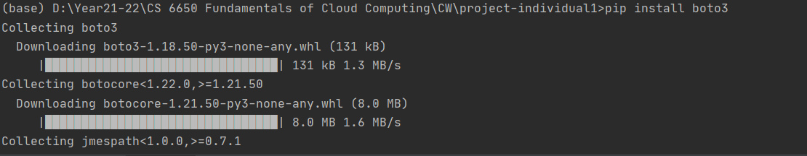

Create Access Key

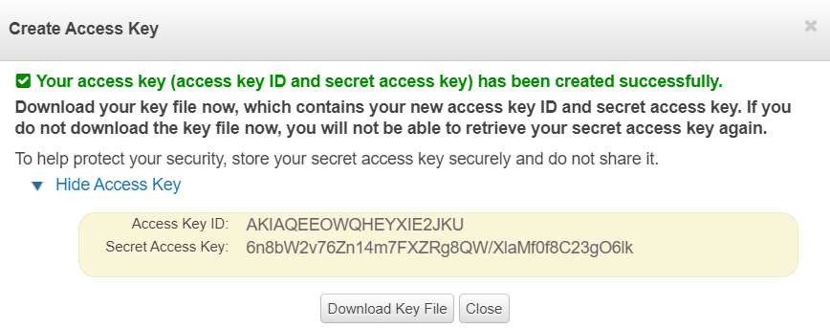

Before coding, I create a security group in case it is needed for instance creation

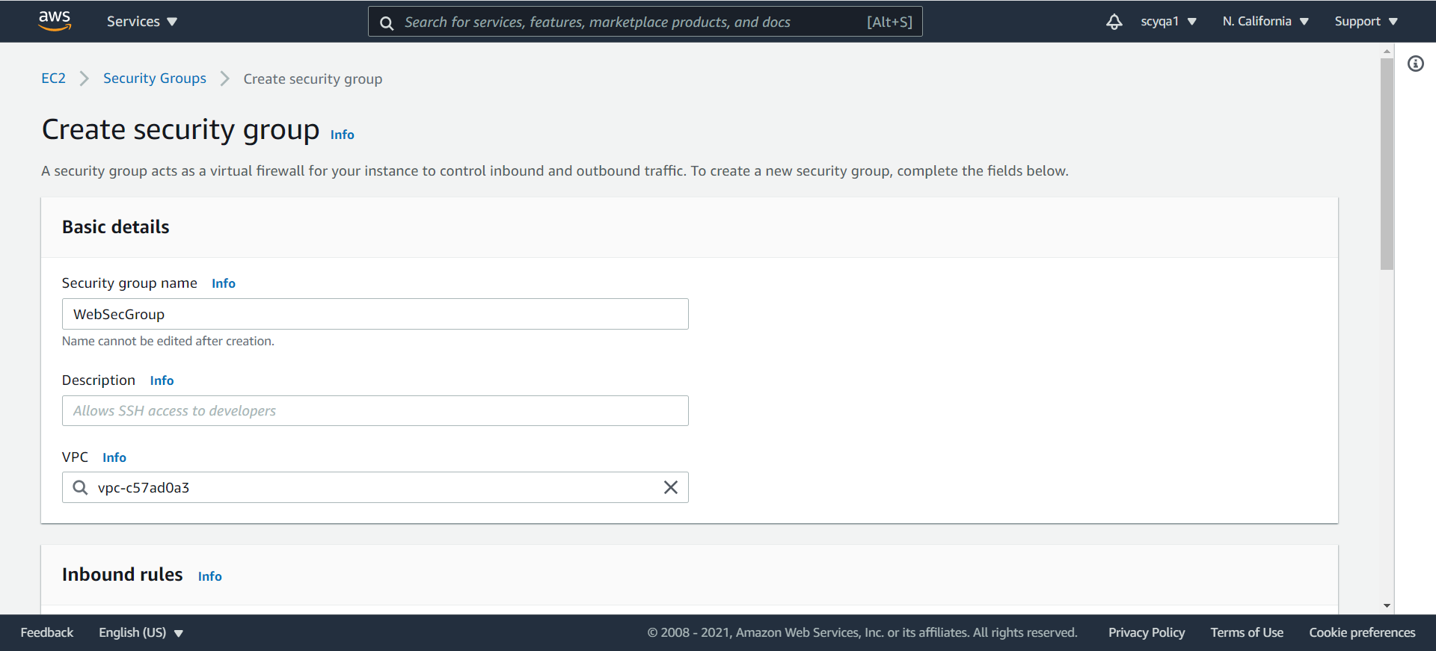

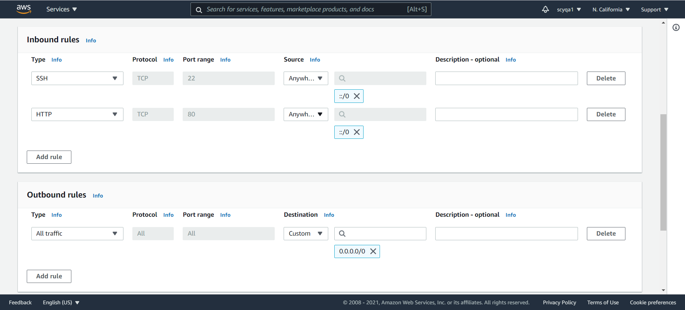

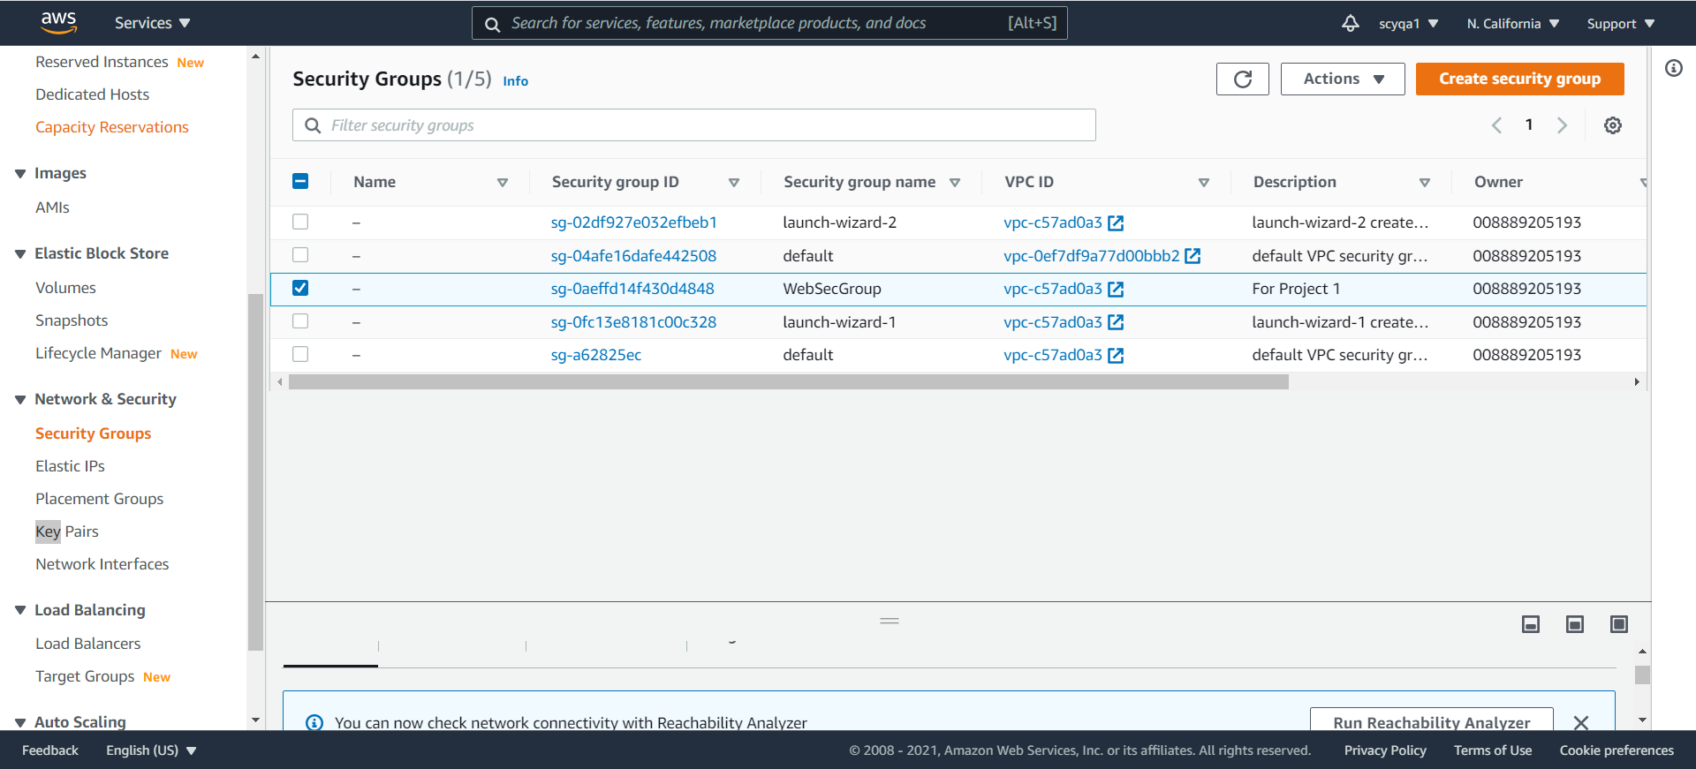

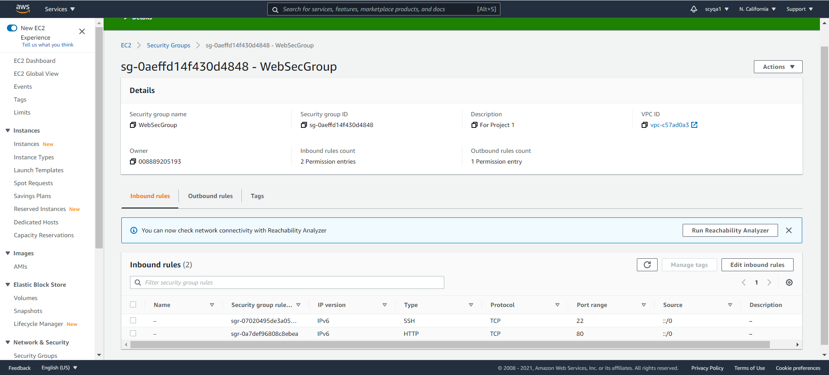

Similarly, I create key pair

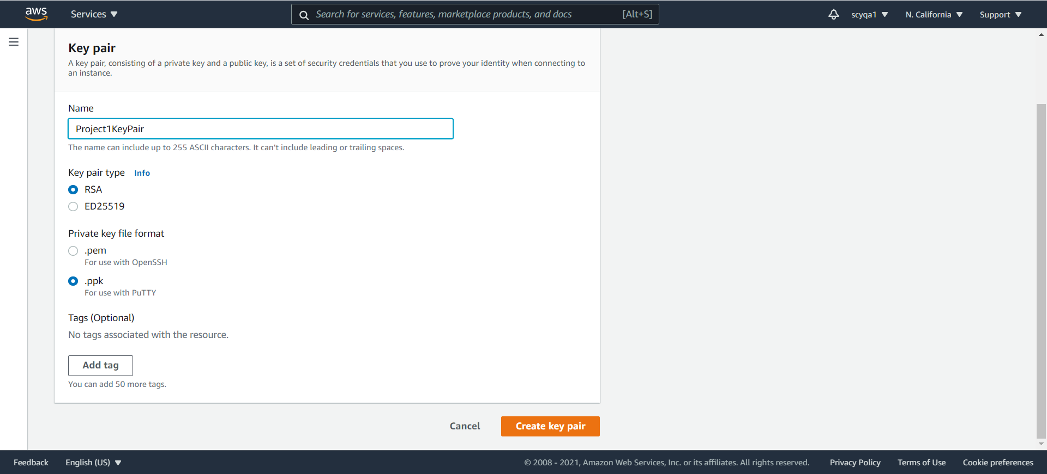

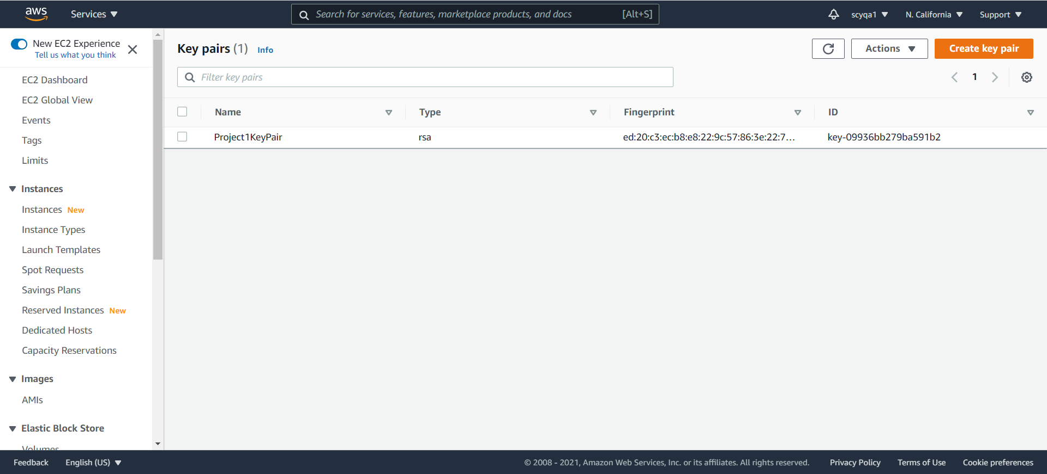

Final Result

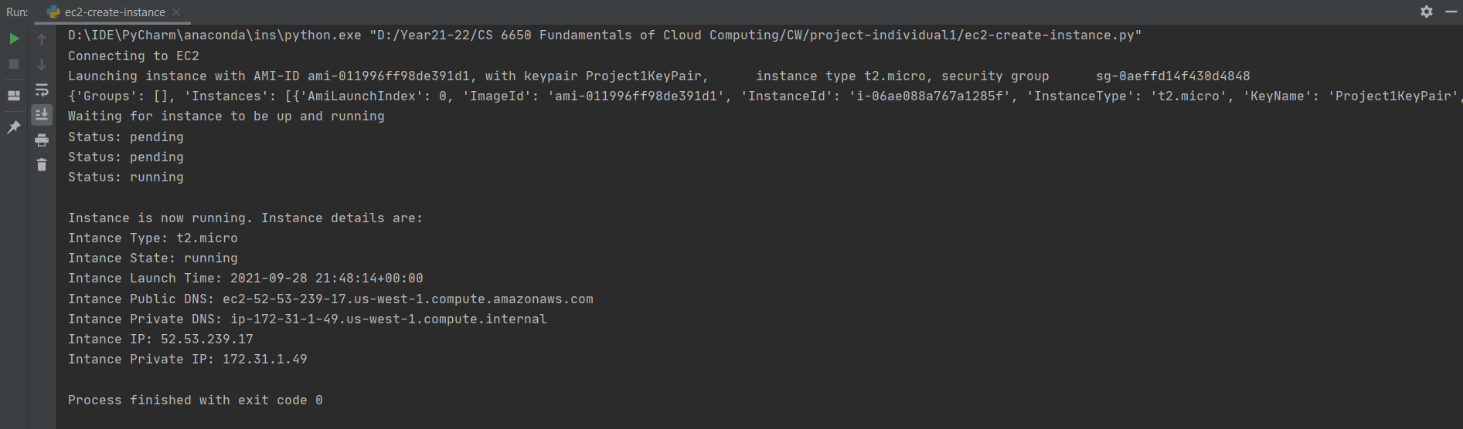

Log on the aws



**2. Modify the EC2 instance initiated from #1 above by assigning a tag to the instance**

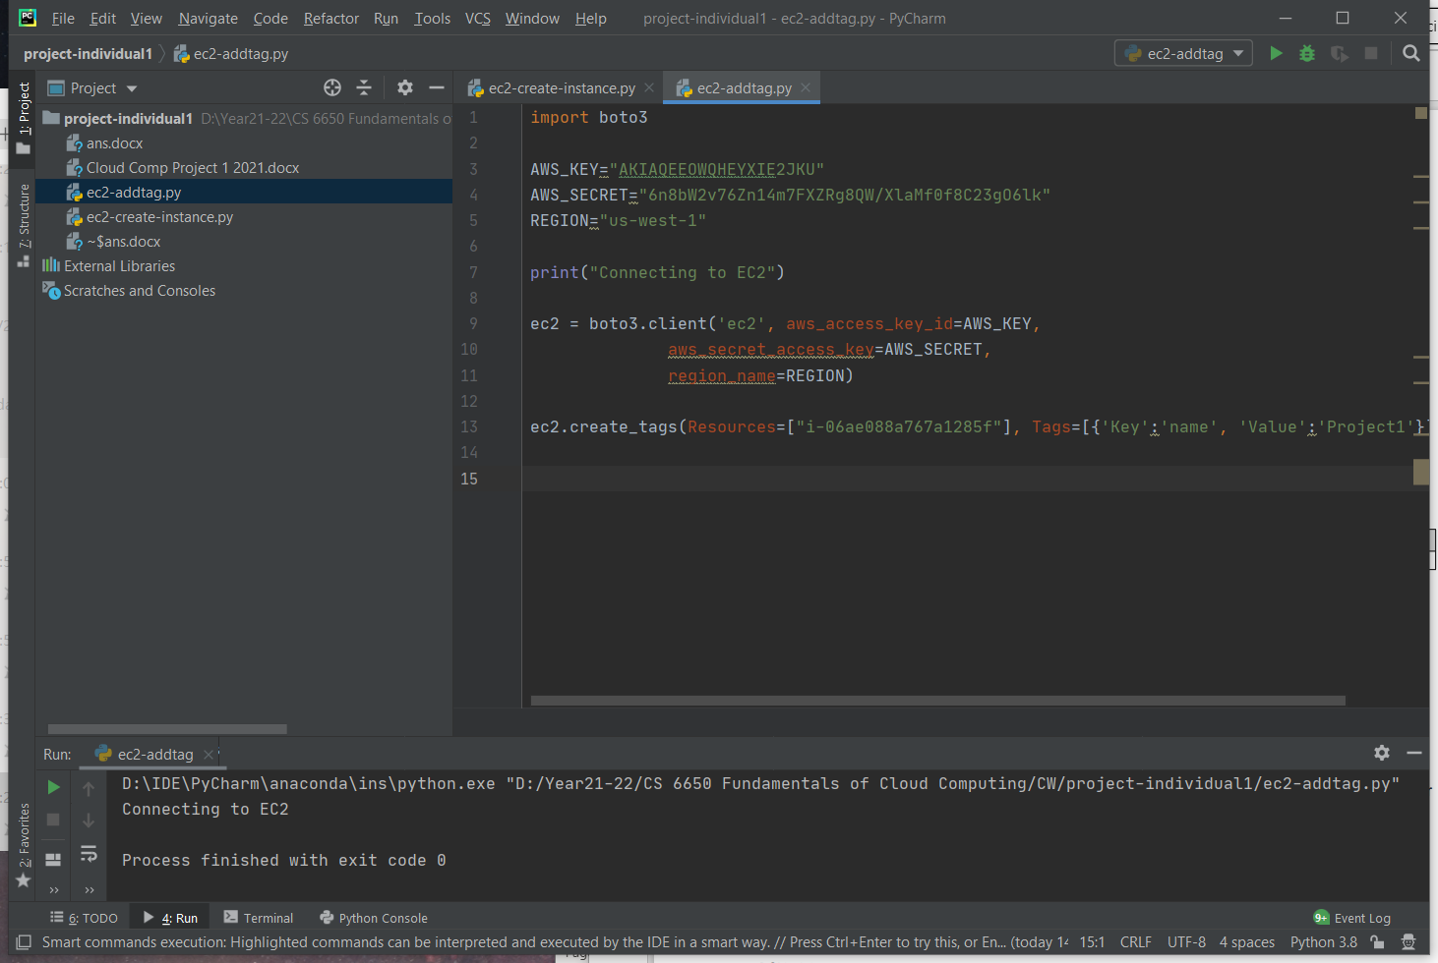

Log on the aws

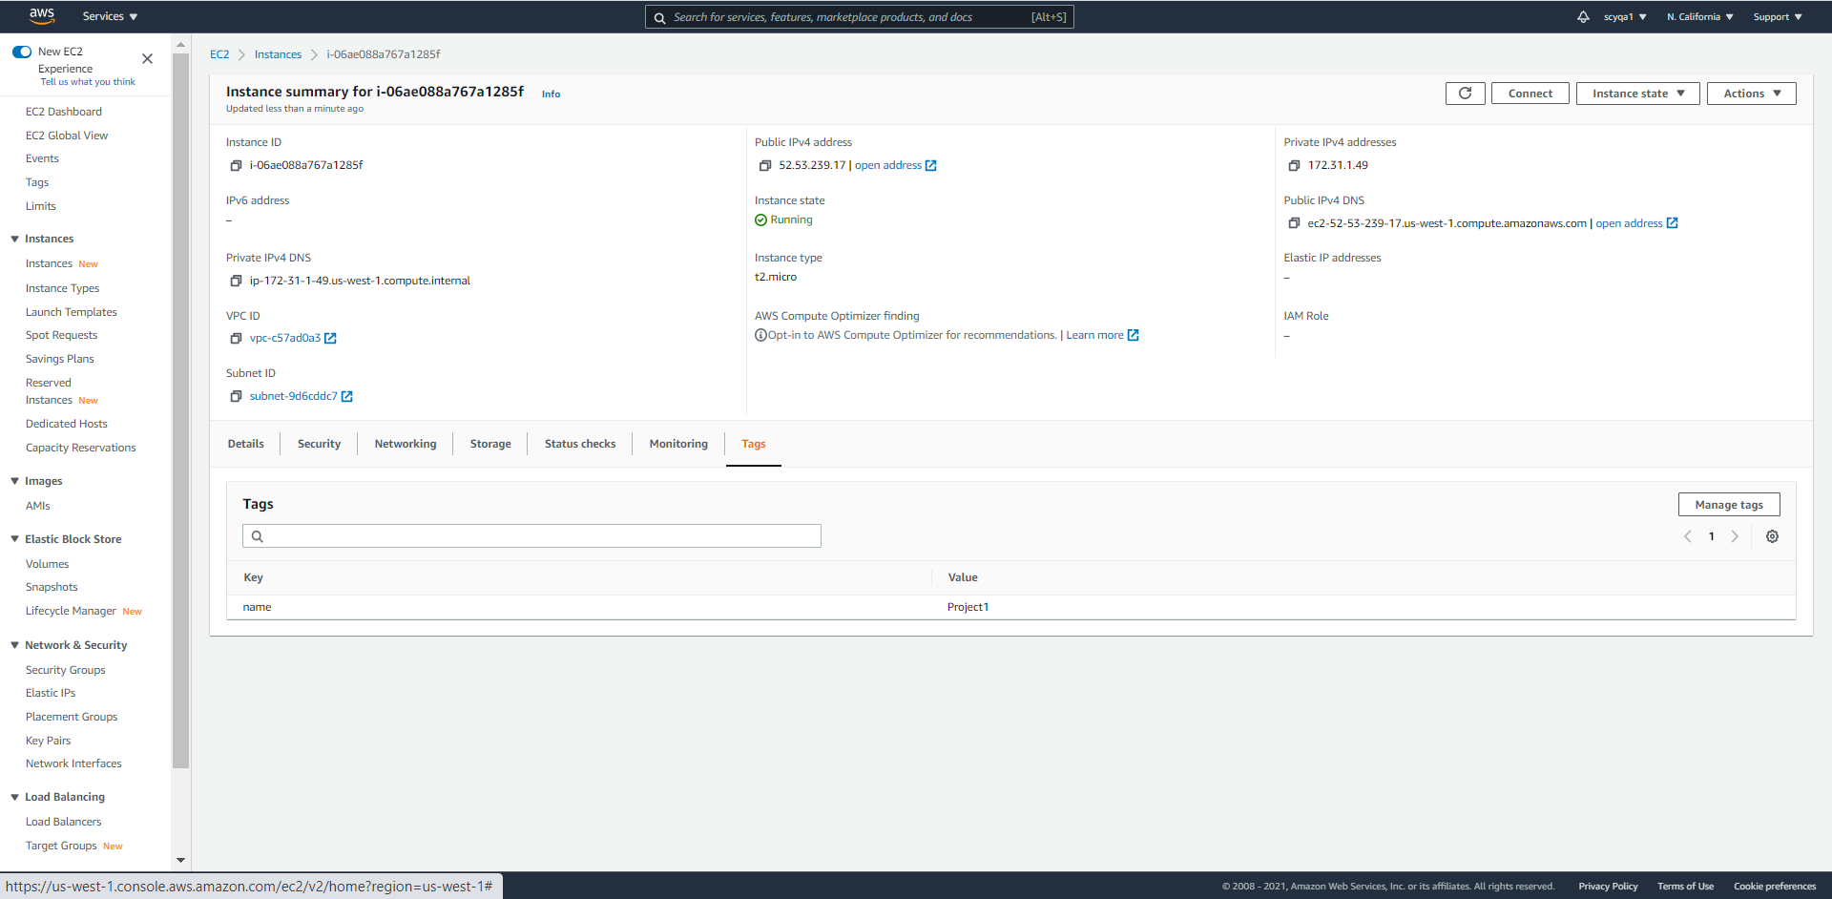

**3. Further modify Q1 to reboot the EC2 instance that you had set up at the beginning**

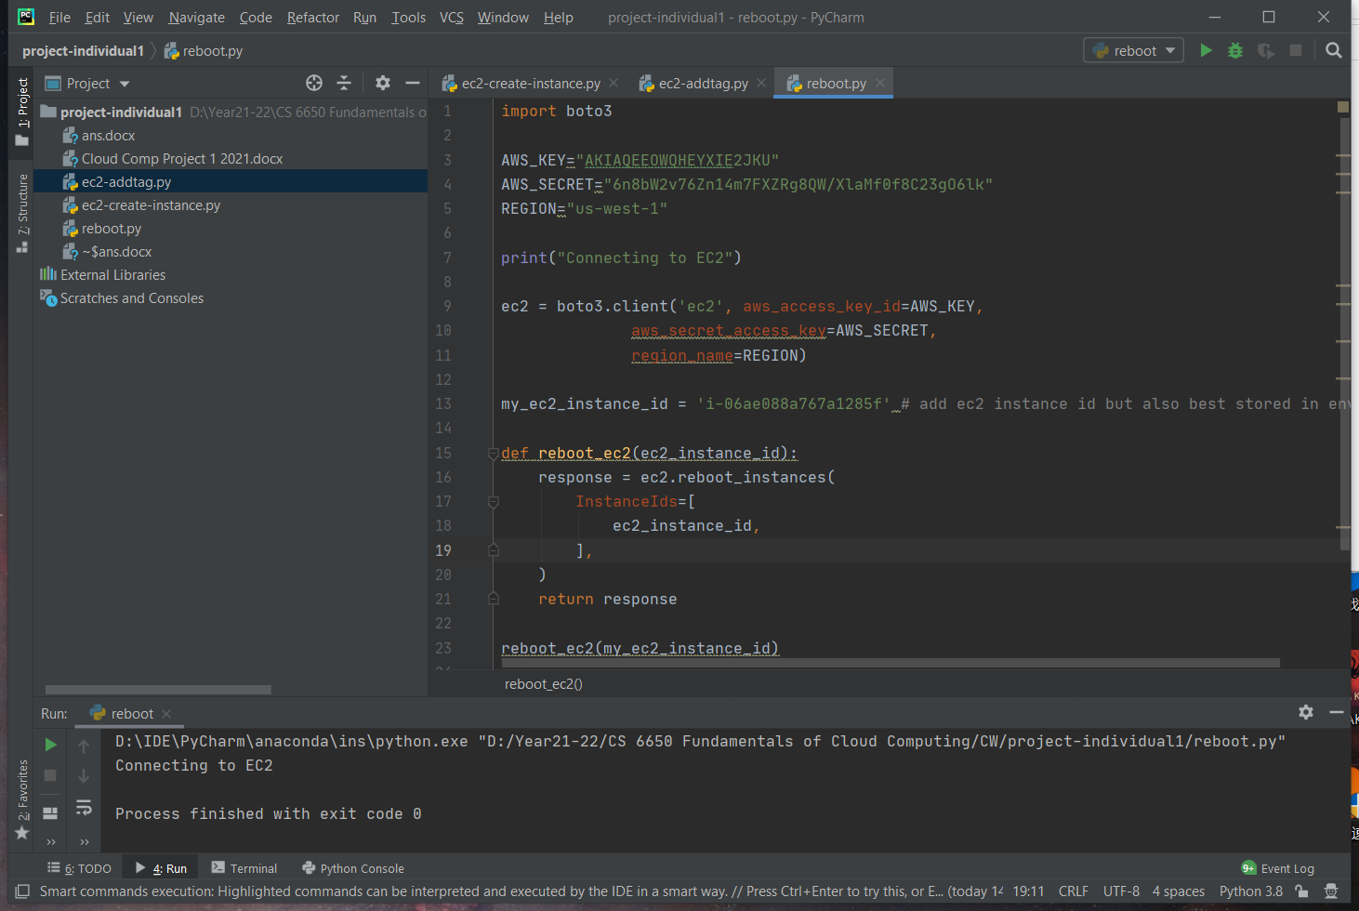



**4. When the entire process of set up has been completed then stop the EC2 instance.**

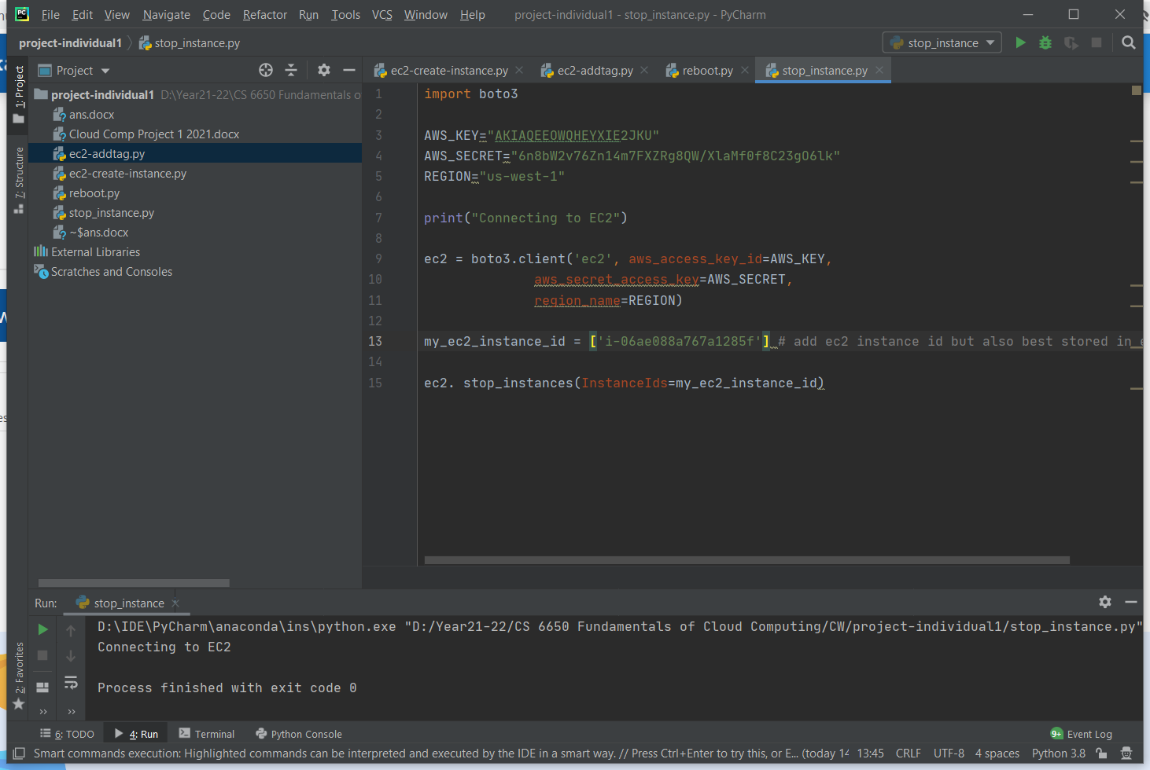



**5. Start 5 to 6 EC2 instances and assign tags randomly ensuring there are 2 different tags in total**

For this part, I launch 5 EC2 instaces, and the first three are with Tag ‘Project1_1’ and the last two are with Tag ‘Project1_2’

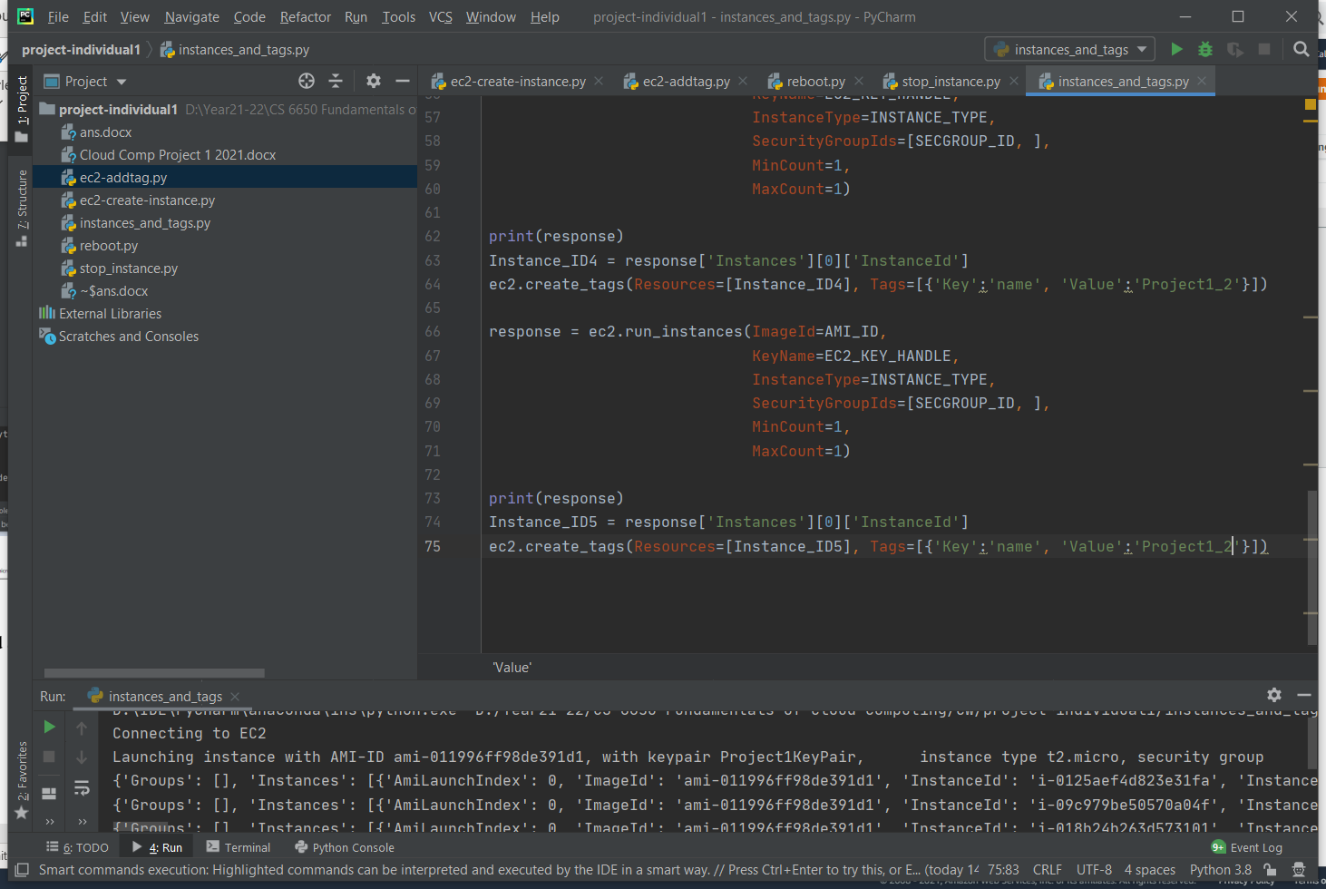

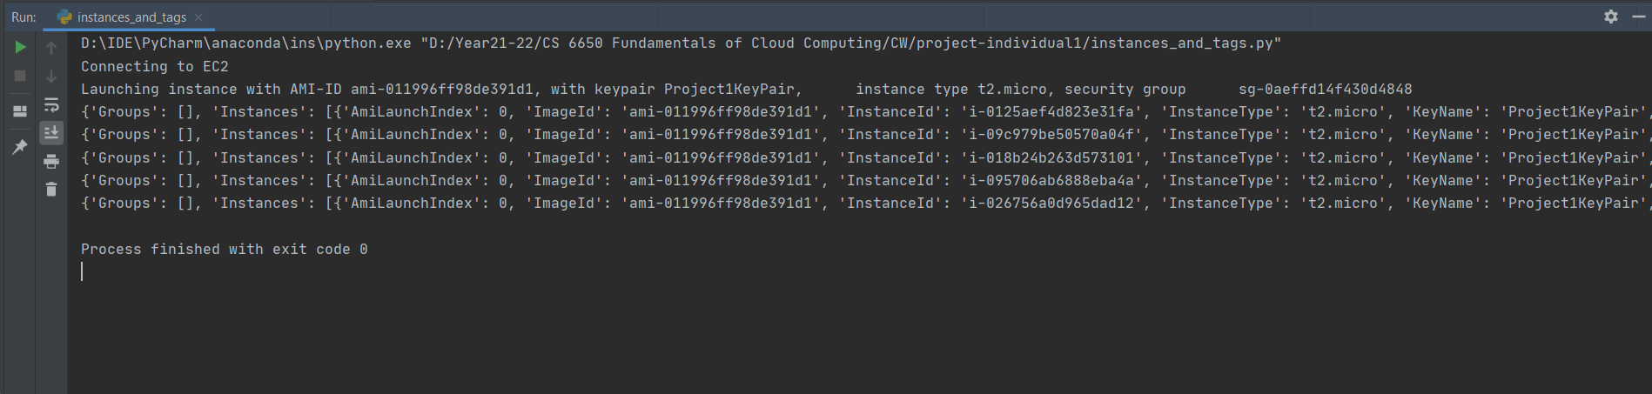

Log on the aws



Project1_1

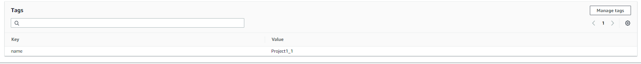



Project1_2





**6. Find all the instance id that are actively running and report the same**

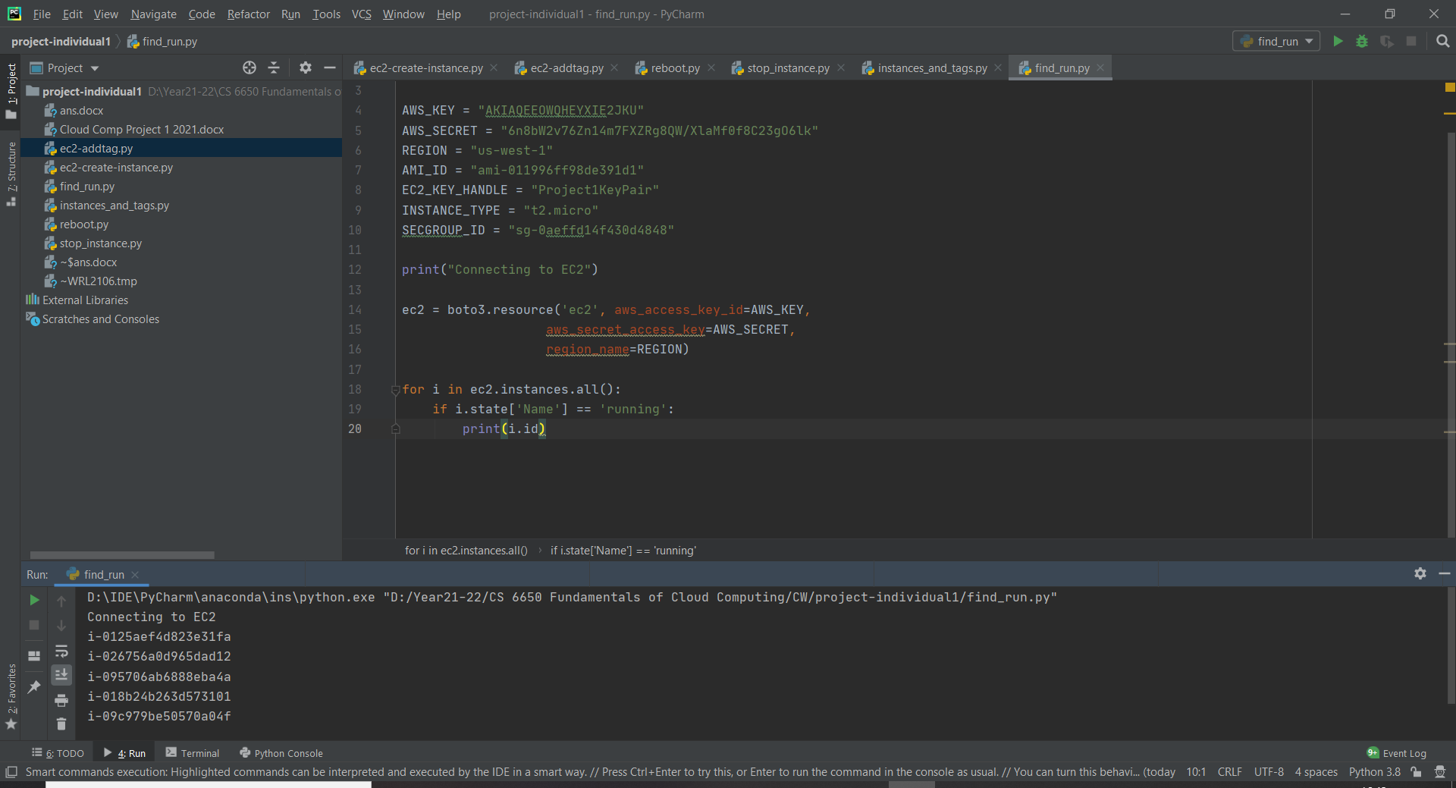

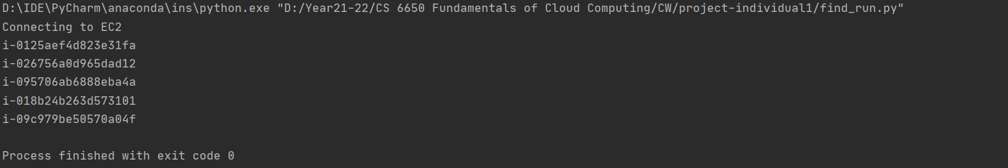

Log on the aws

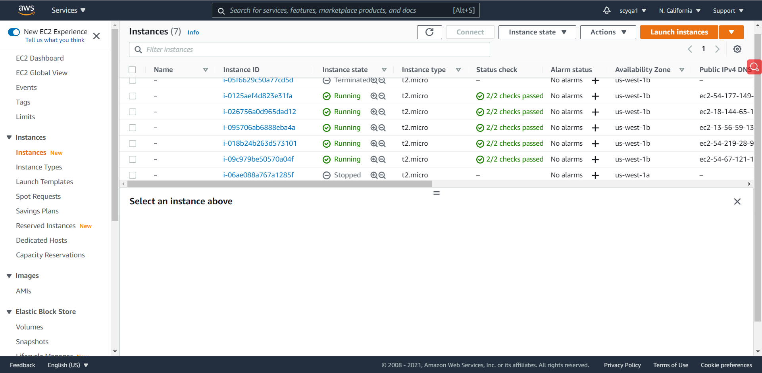

**7. Filter the EC2 instance based on tags**

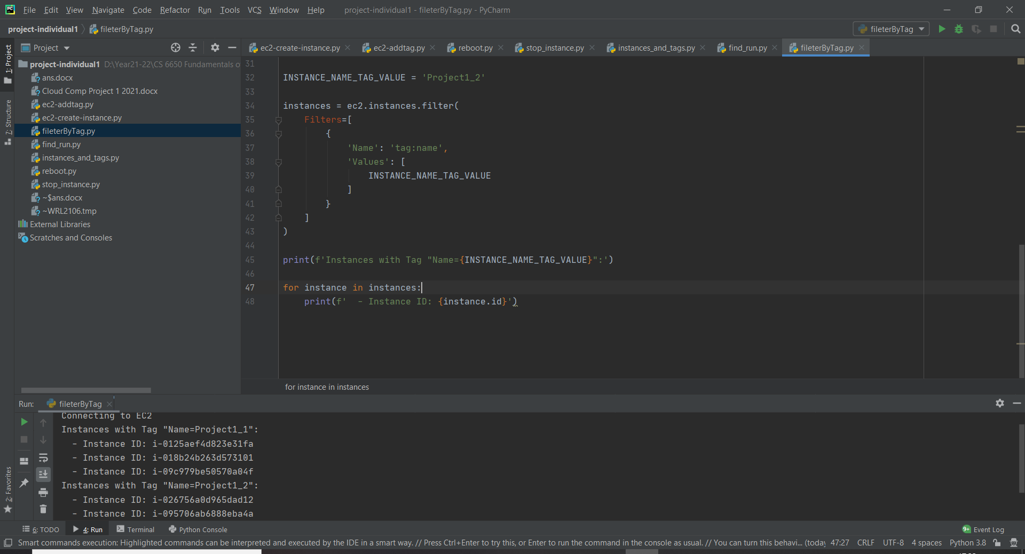

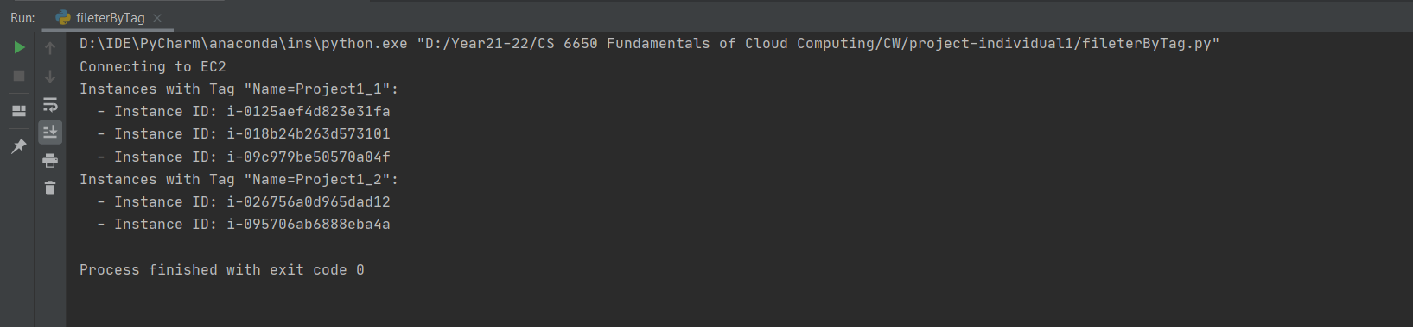

**8. Describe the properties of all the EC2 instances**

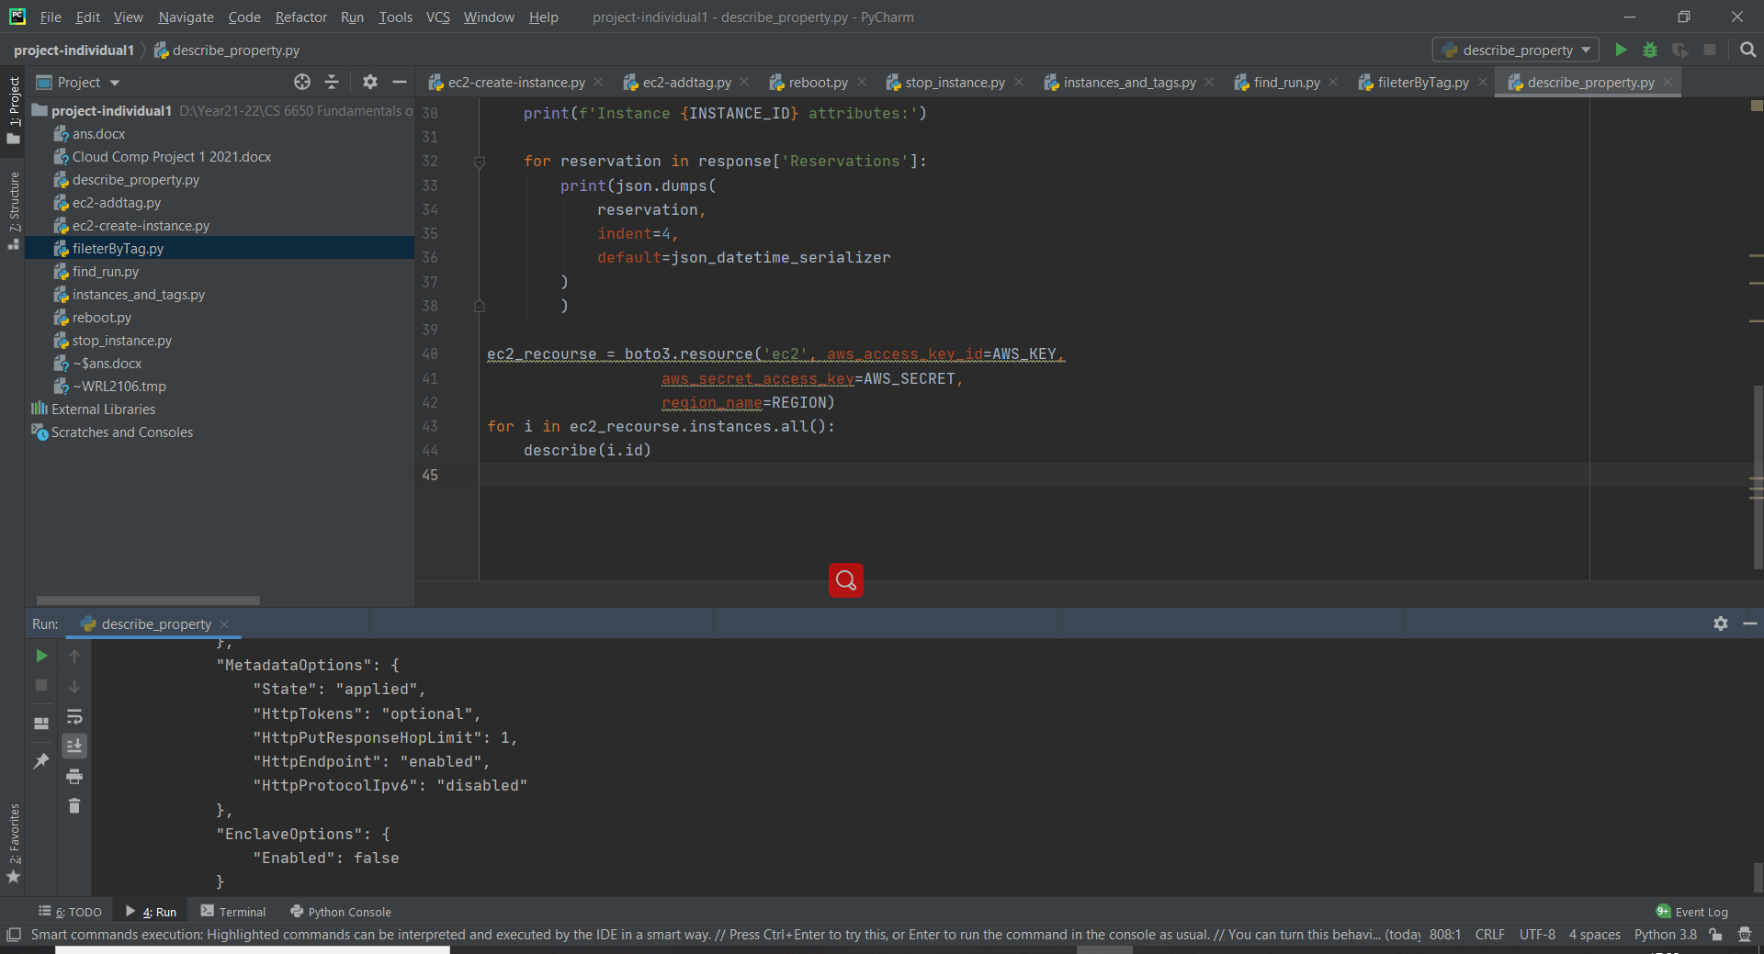

The ouput would be in a json format

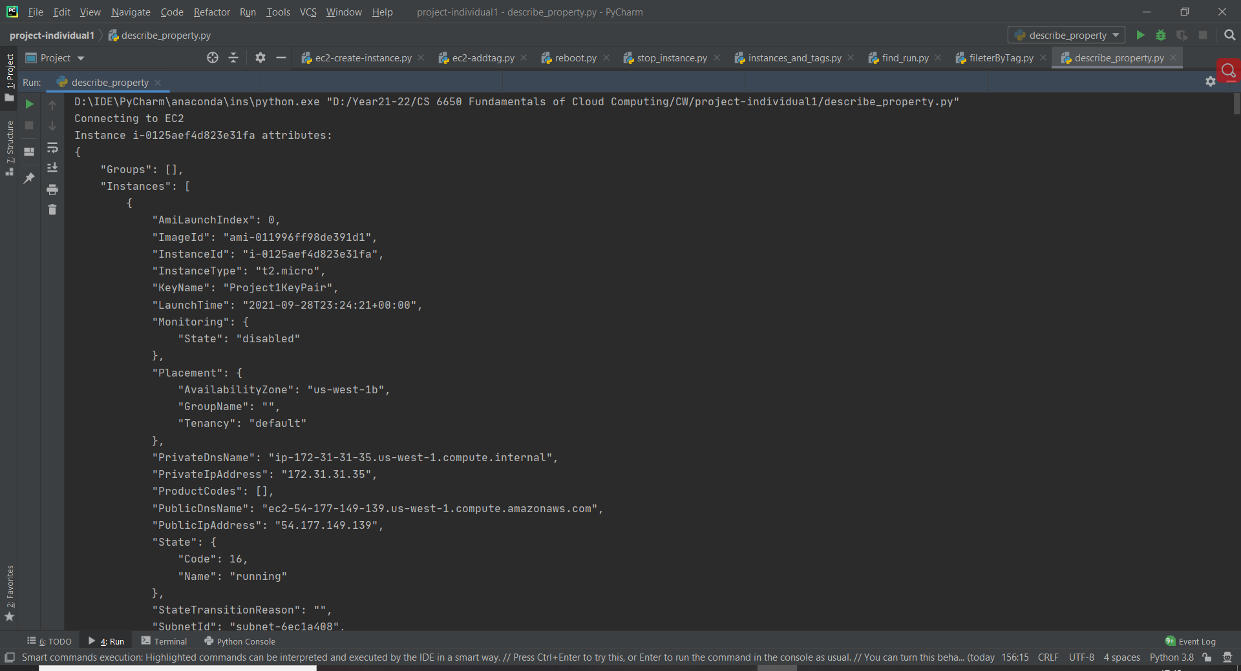

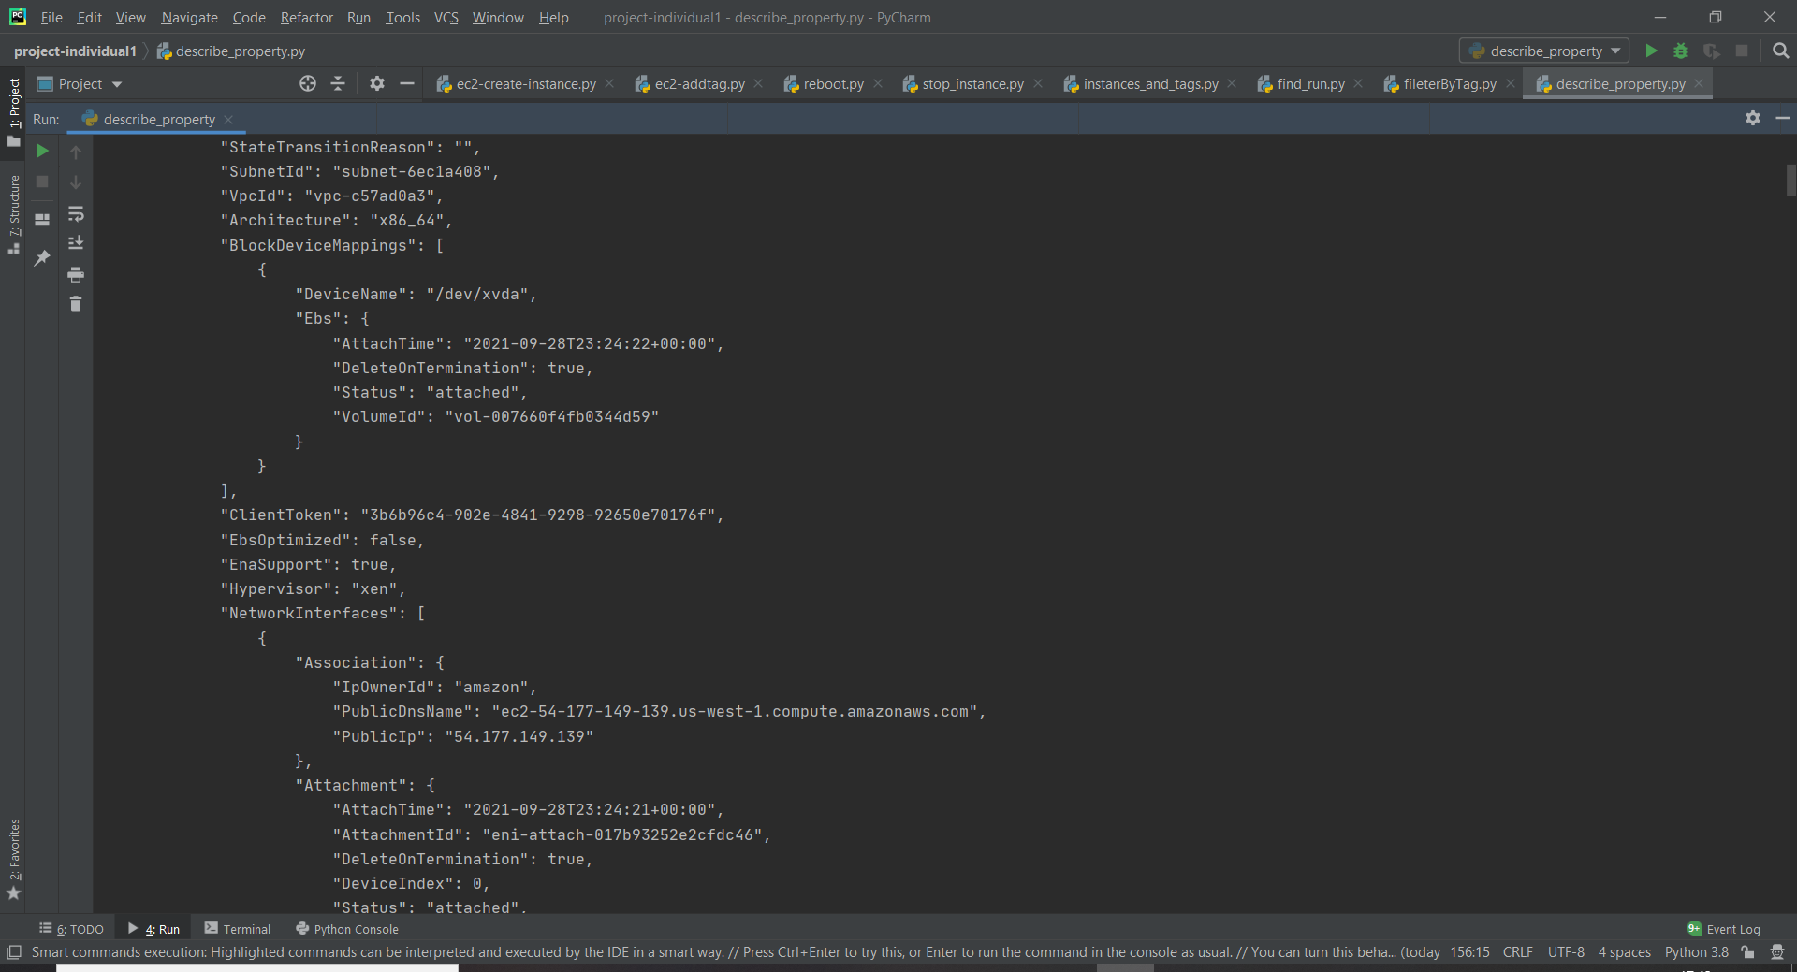

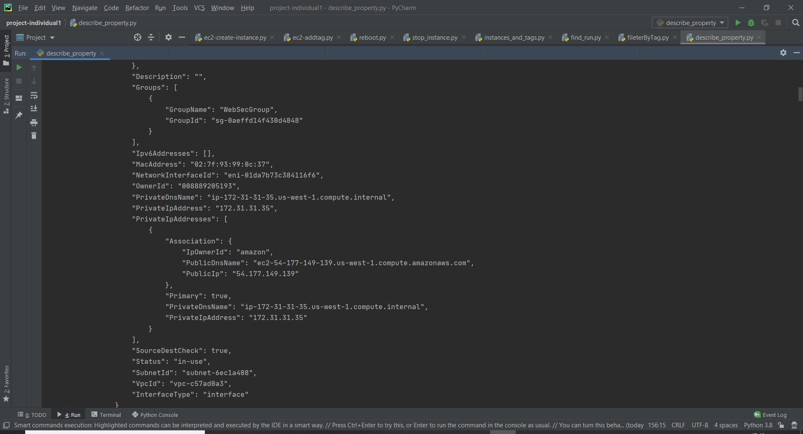

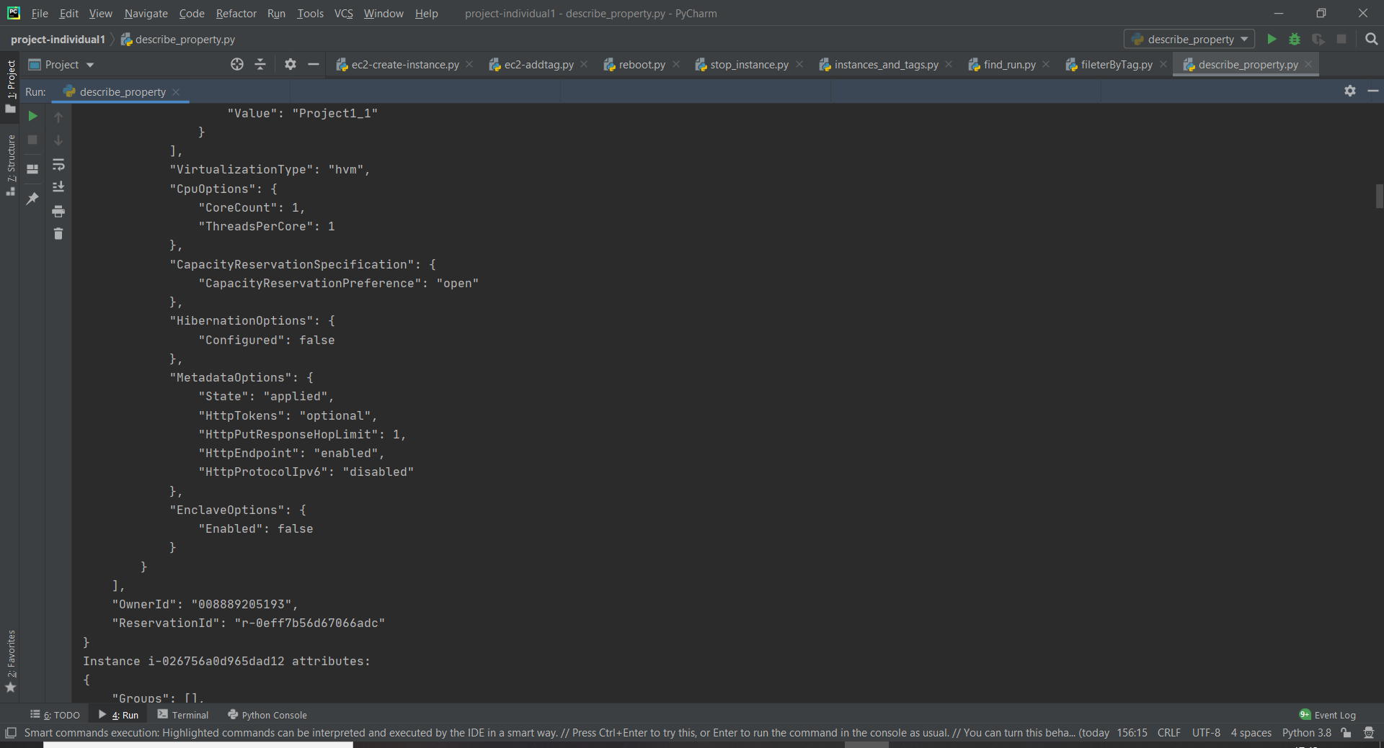

As you can see from the progress bar on the right side of the terminal, there are too many properties, so that I don’t include all the screenshots.

**9. Update the tag to make sure that there is only one tag that is assigned to all the ec2 instance**

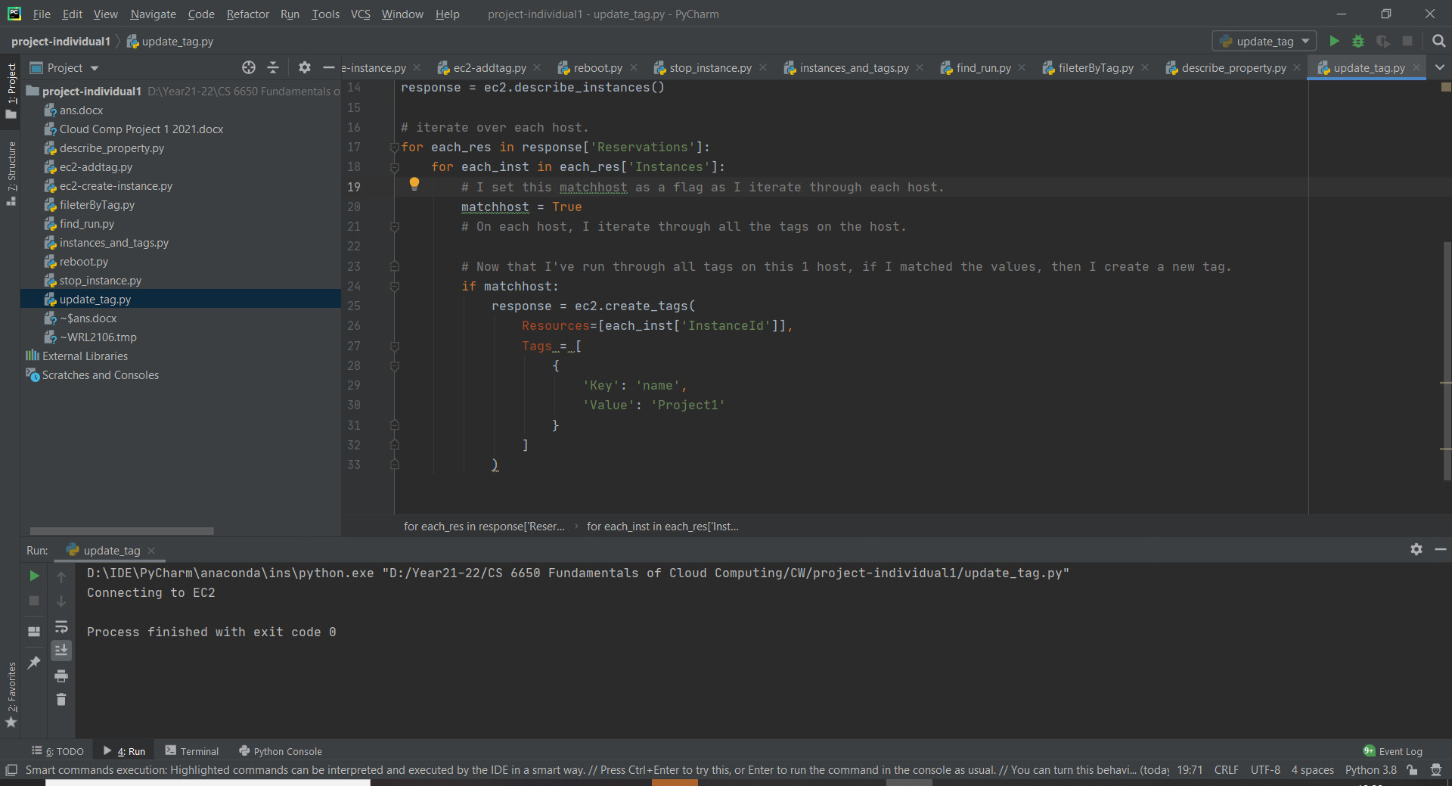

By the function of ‘create_tags’, all tags could be updated to new tag ‘Project1’

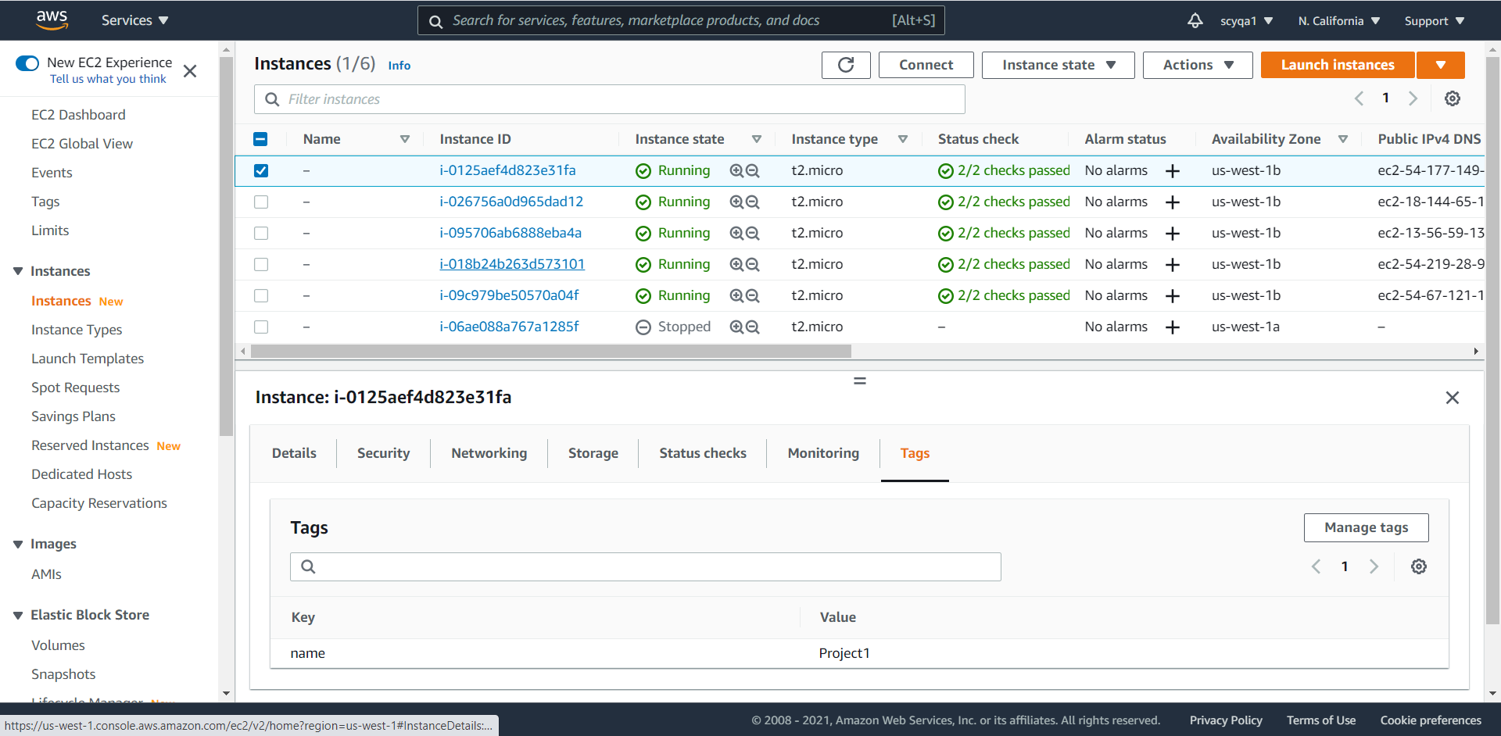

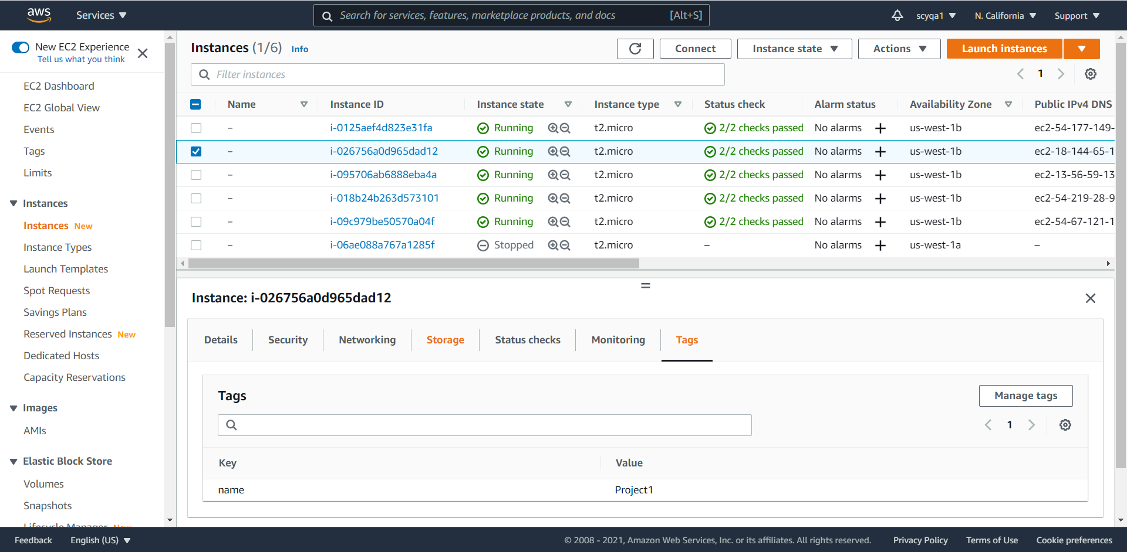

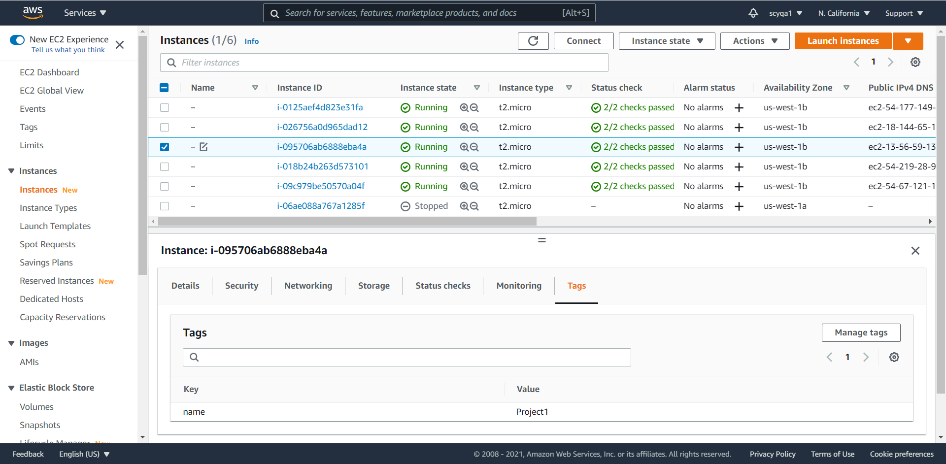

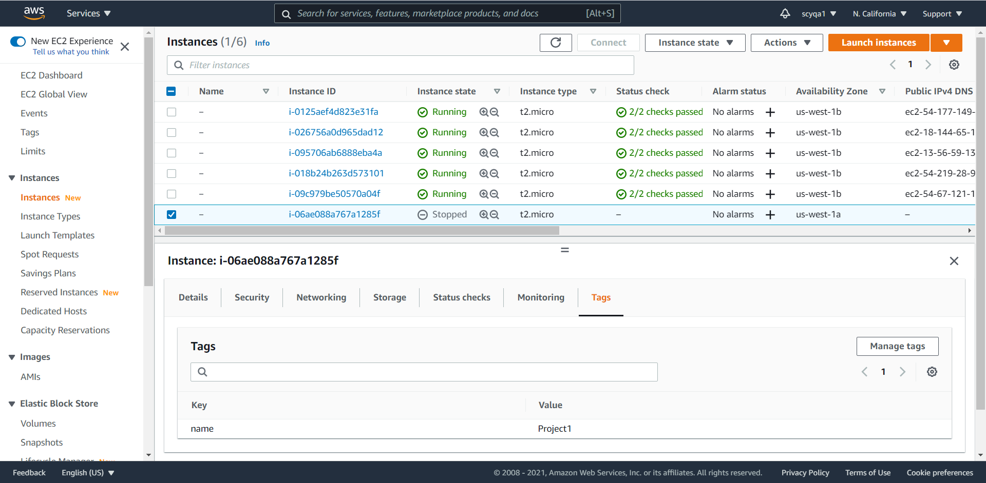

**10. List all the instance id and their tags**

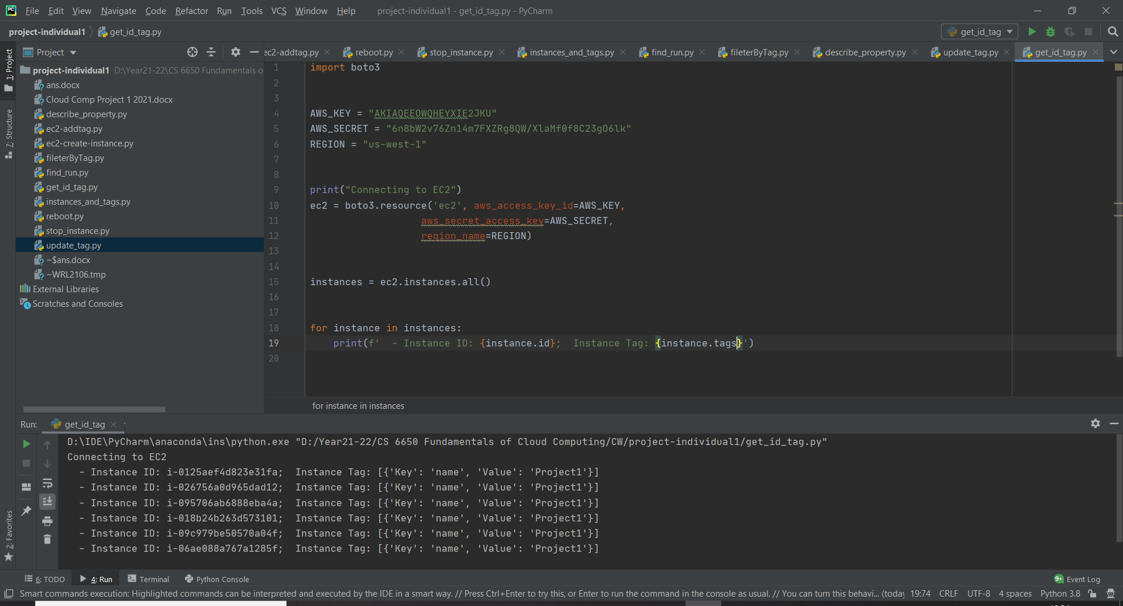

**11. Stop all the instances using the instance id’s**

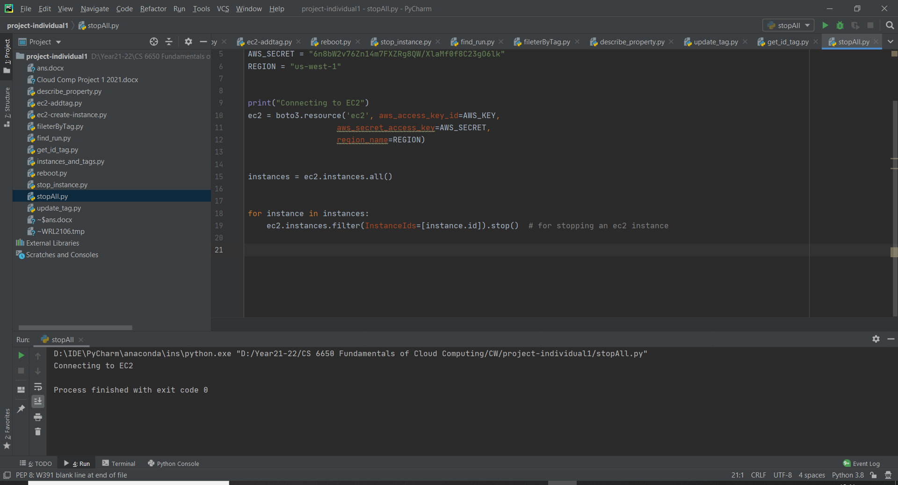

Log on the aws

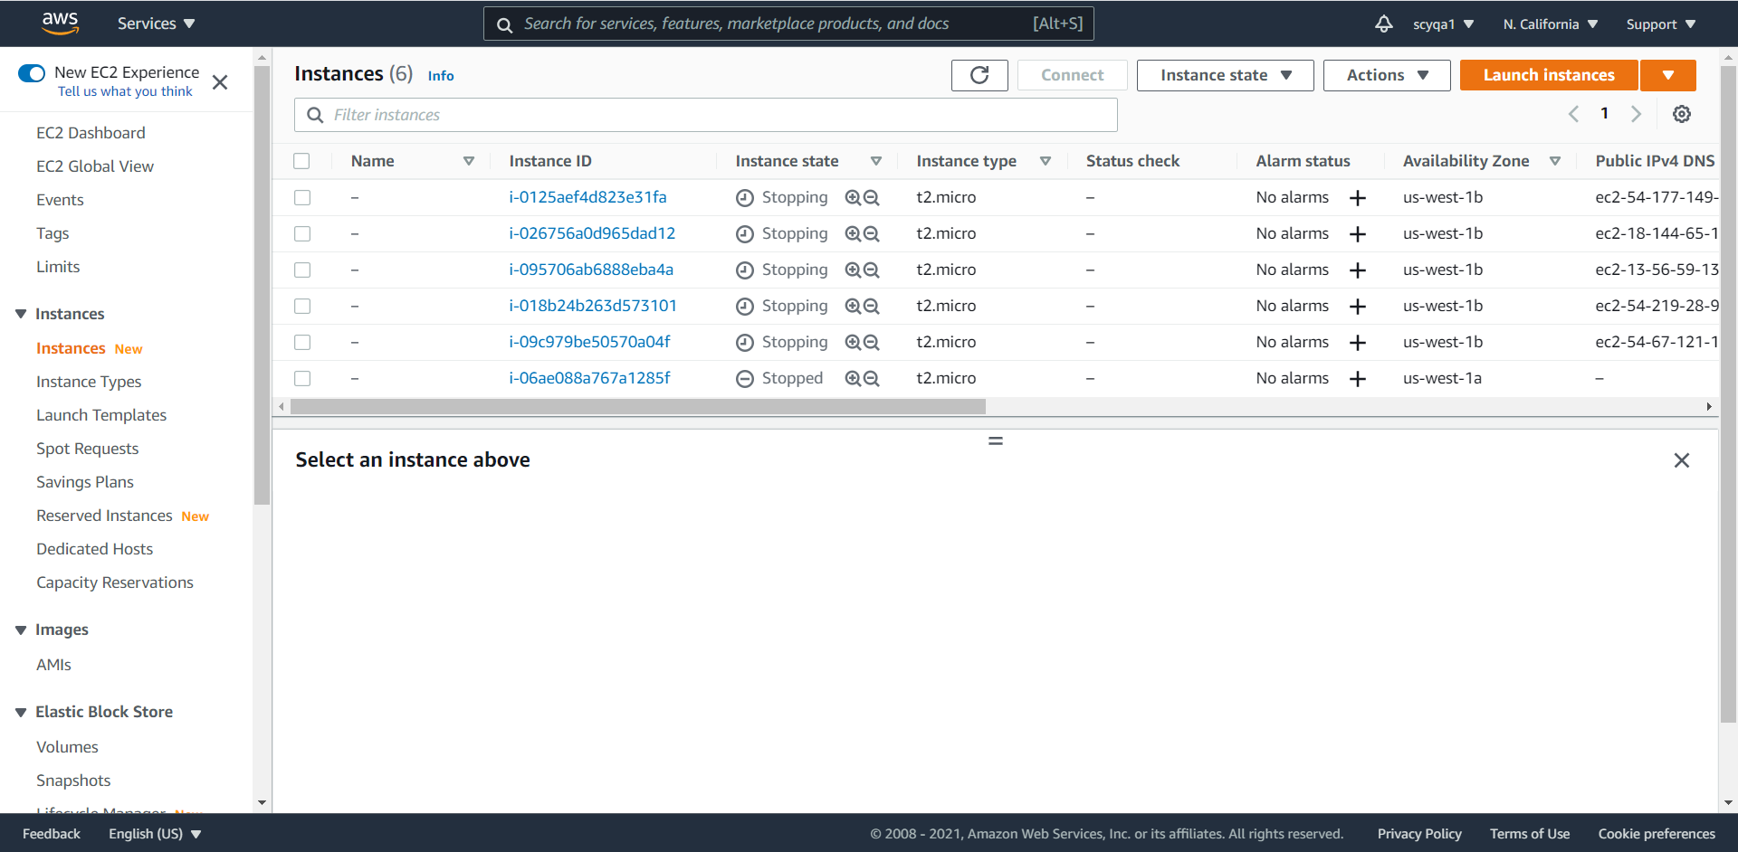

Part 2

**1)Set up the EC2 instance, using t2.micro, add tag to it and it has to be accessed via any IP address**

Step 1: choose an Amazon Machine Image (AMI)

I select the Amazon Linux 2 AMI.

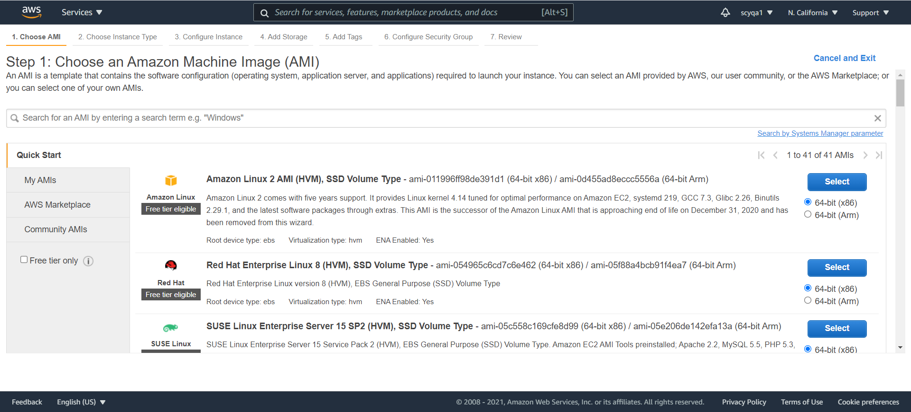

Step 2: choose an instance type

I select the type ‘t2.micro’.

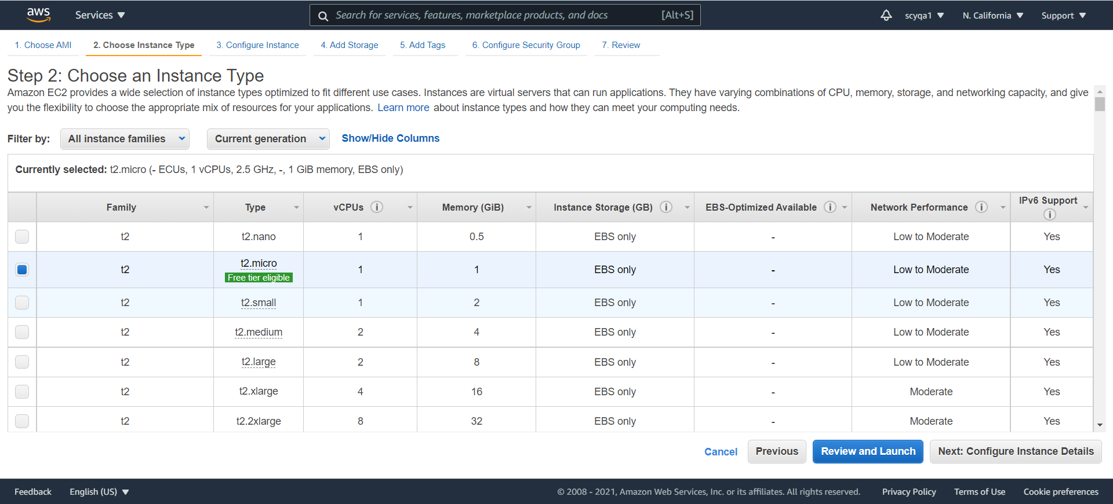

Step 3: configure instance details.

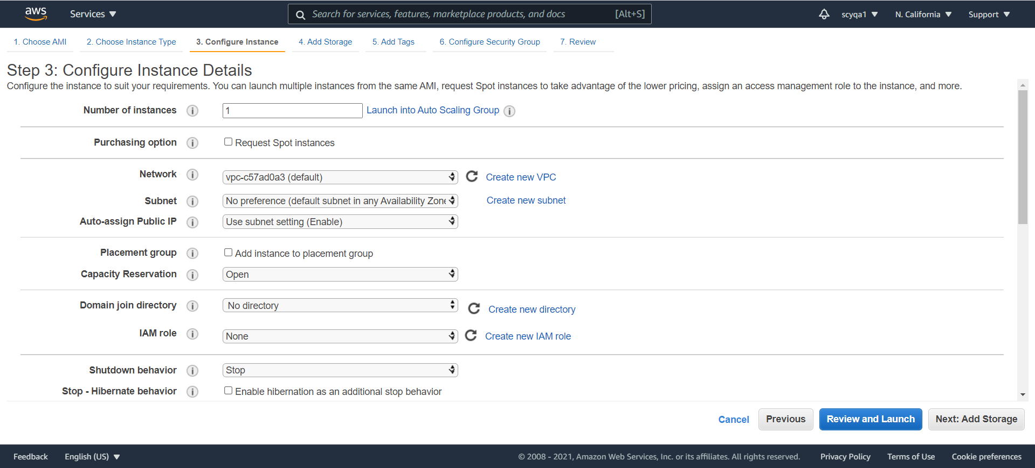

Step 4: add storage.

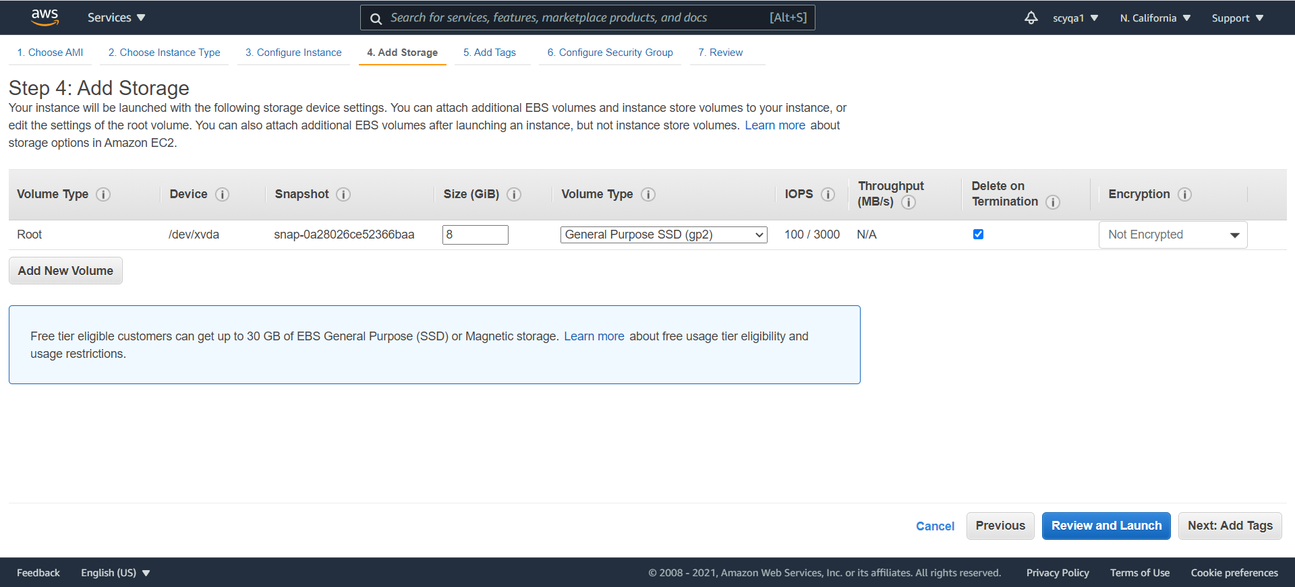

Step 5: add tags

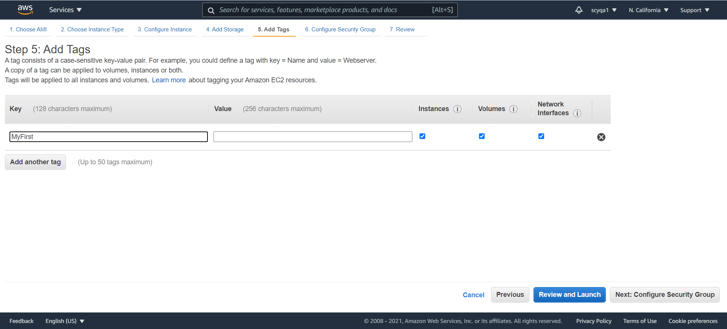

Step 6: configure security group

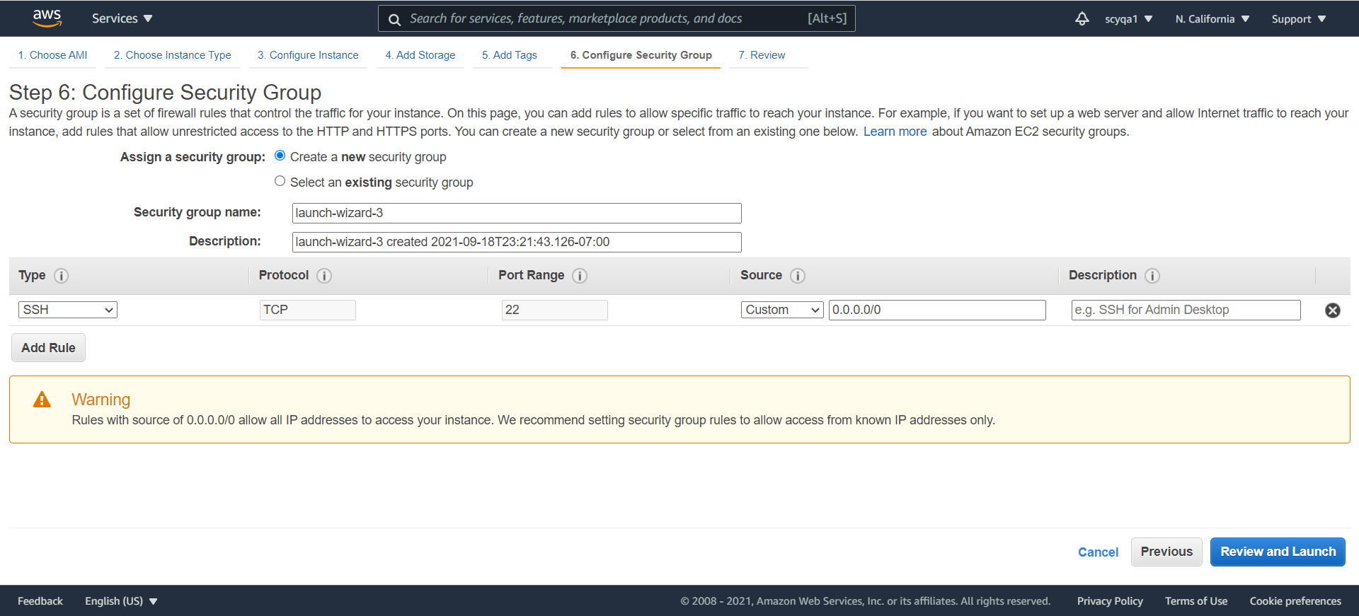



According to the figure about security group configuration above, the inbound rules of source is anywhere, and the outbound rules is all traffic. So it can be accessed via any IP address.

Final result

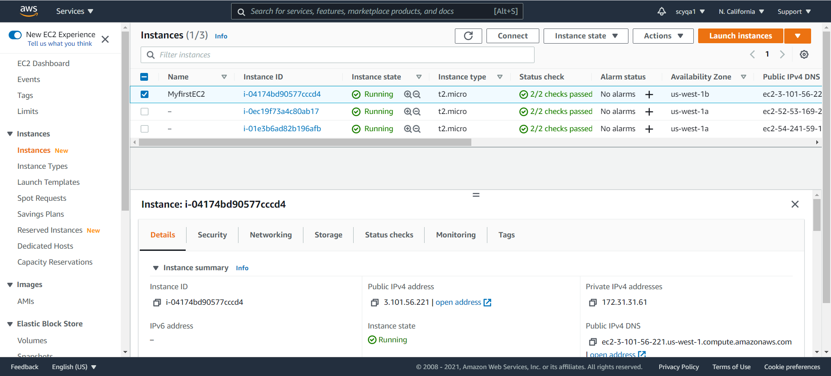

**2)Explain in brief the process by setting up a routing table**

The following figure shows the routing of a VPC with both an Internet gateway and a virtual private gateway, as well as a public subnet and a VPN-only subnet.

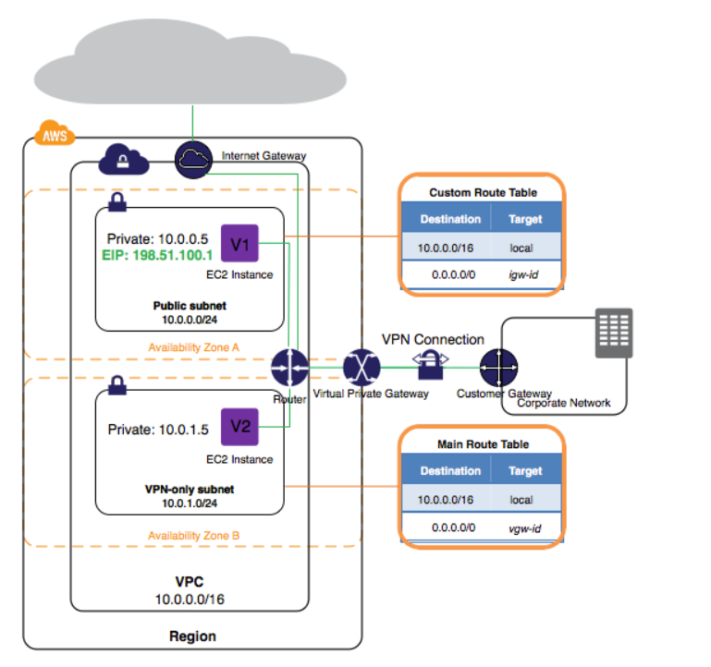

Using Amazon Web Services, I can create route table in VPC services.

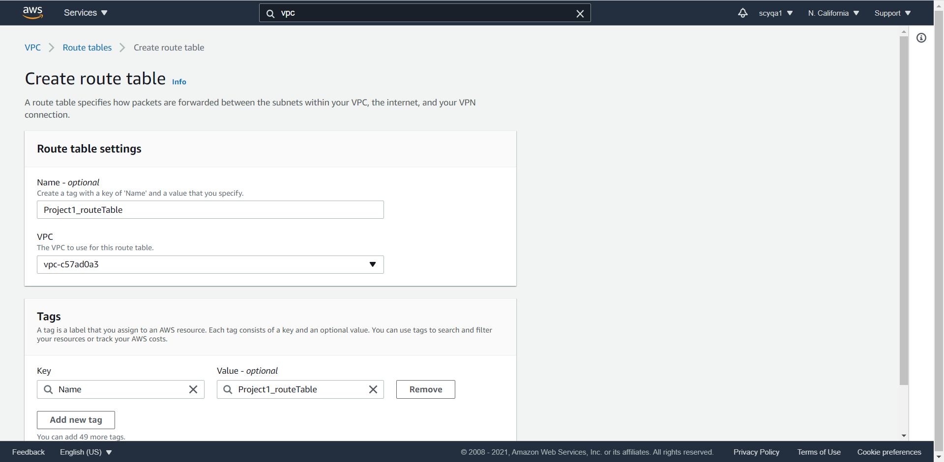

Create route table

In the process, I need to choose a Virtual Private Cloud line to be used for the route table.

Result:

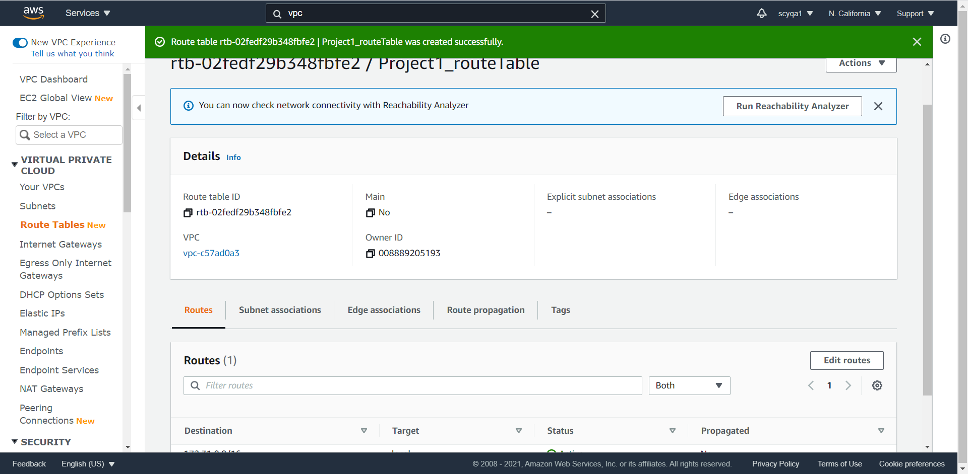

**3)Set up an Application Load Balancer in the console**

Step 1: create target group

Configure settings.

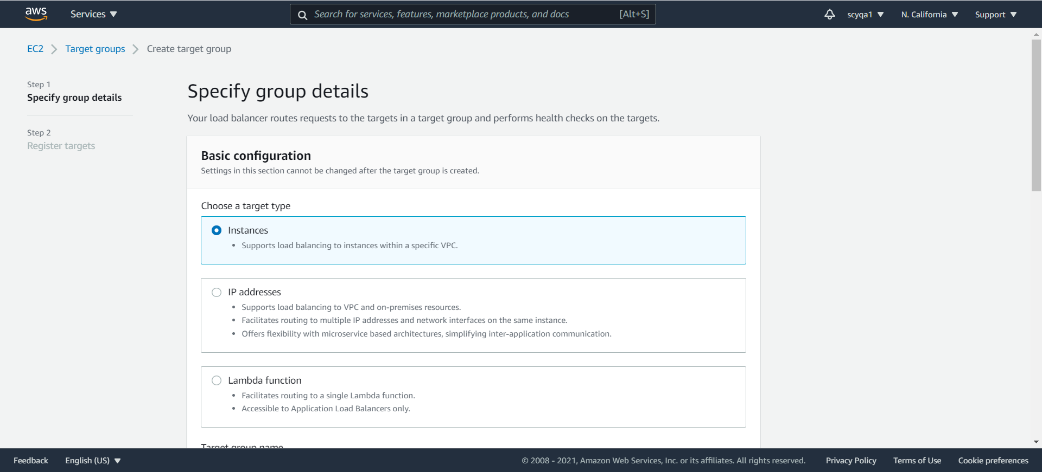

Register targets.

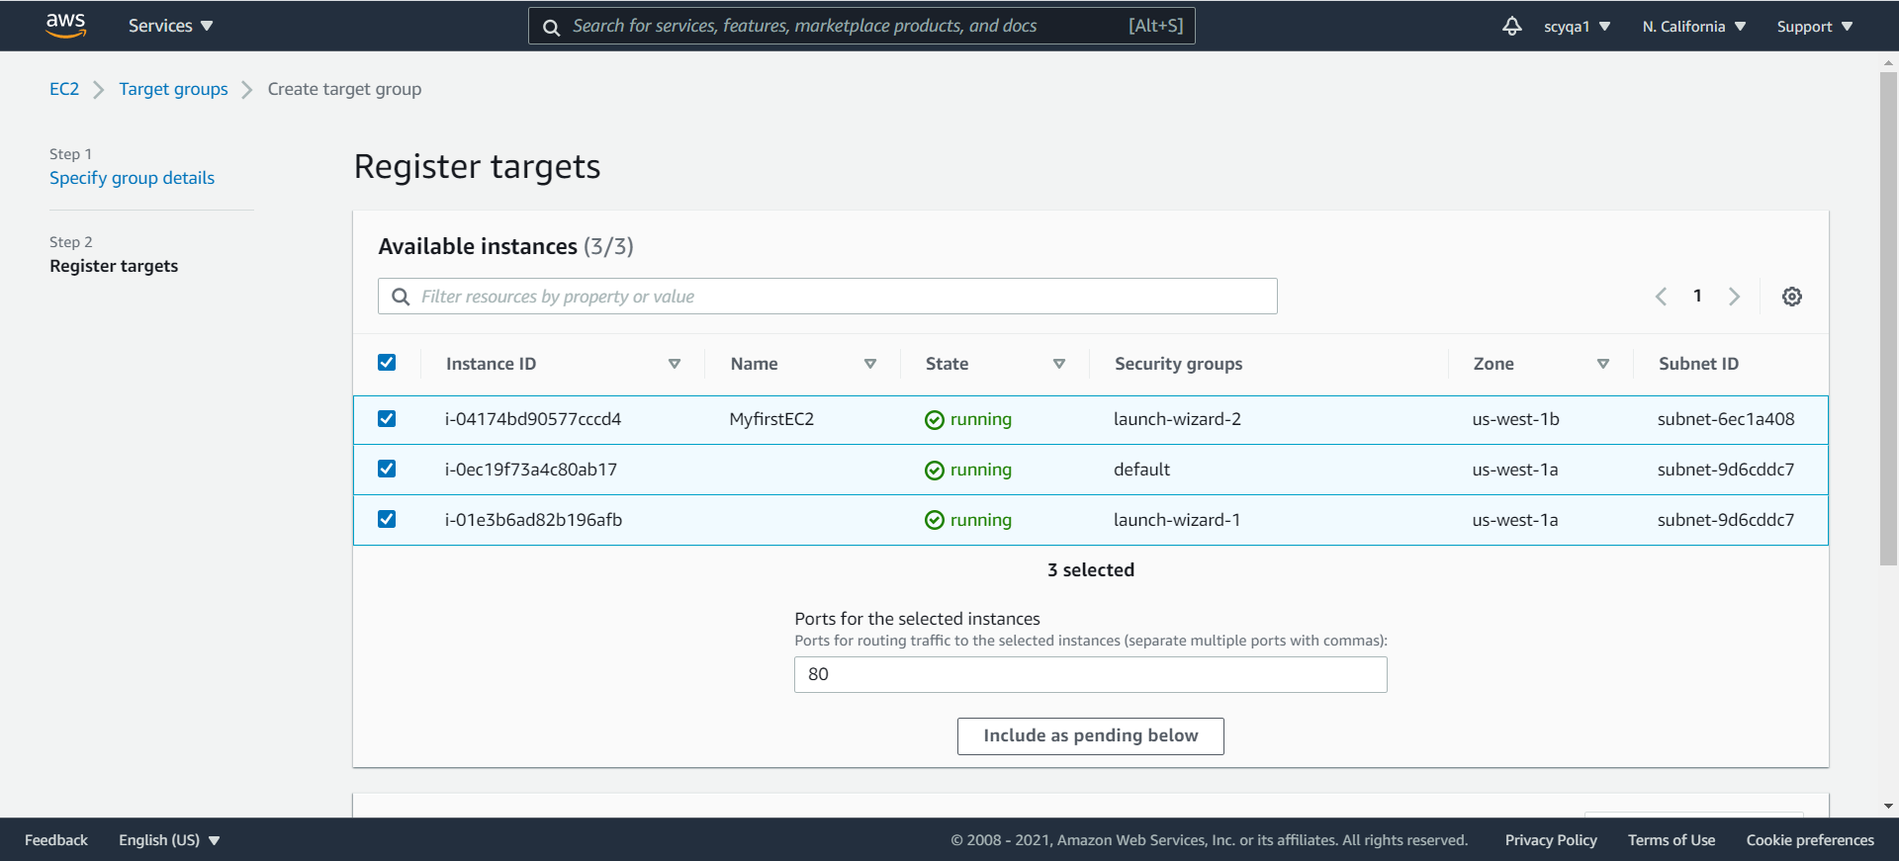

Result

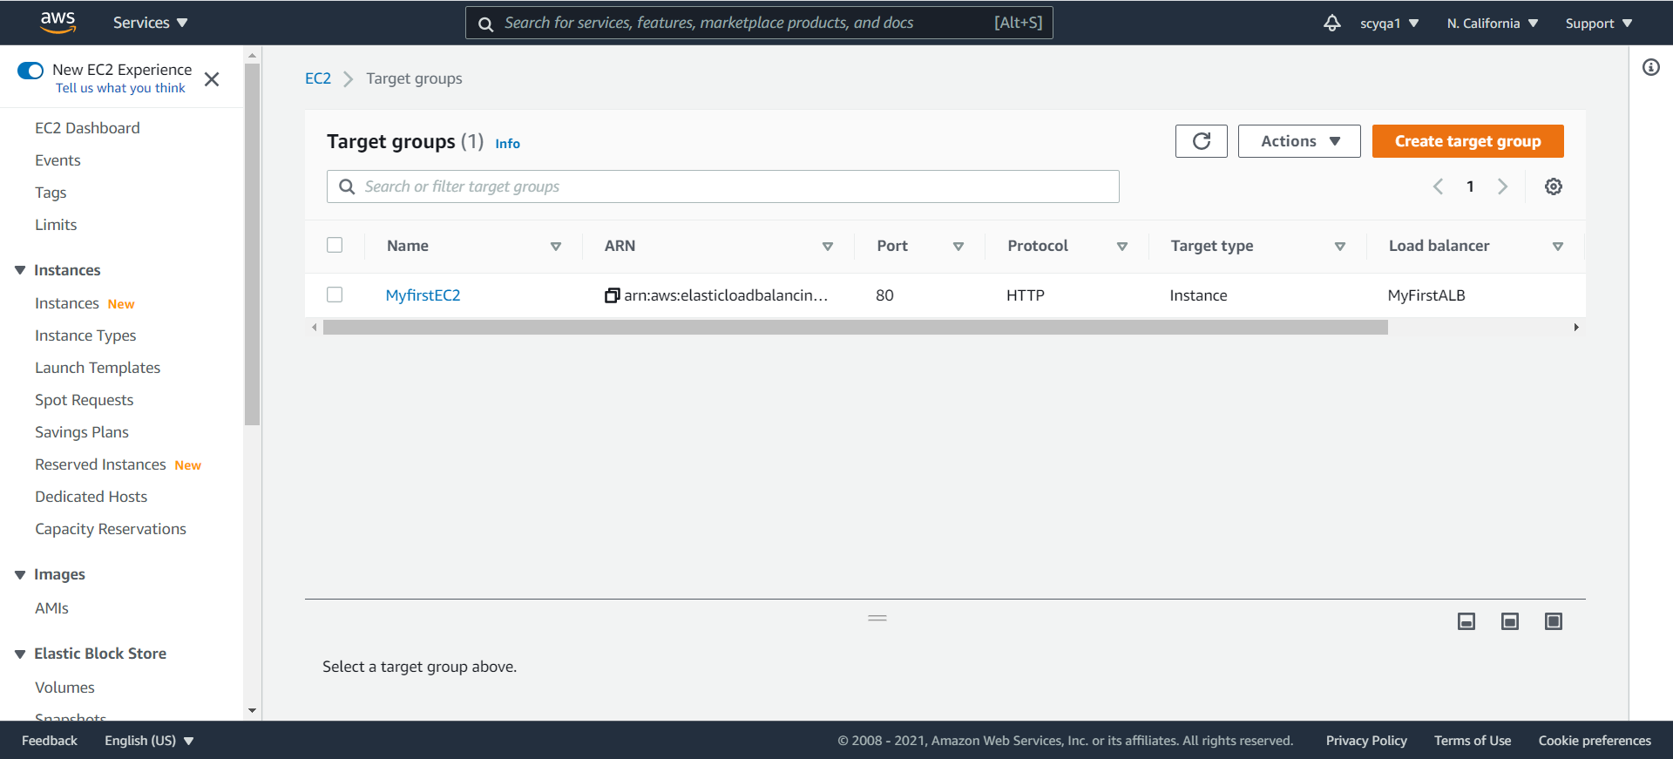

Step 2: create load balancer

Create load balancer type. I select the application load balancer.

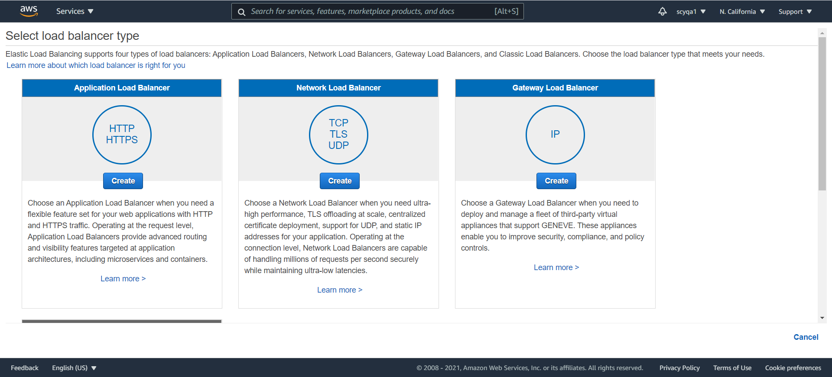

Configure.

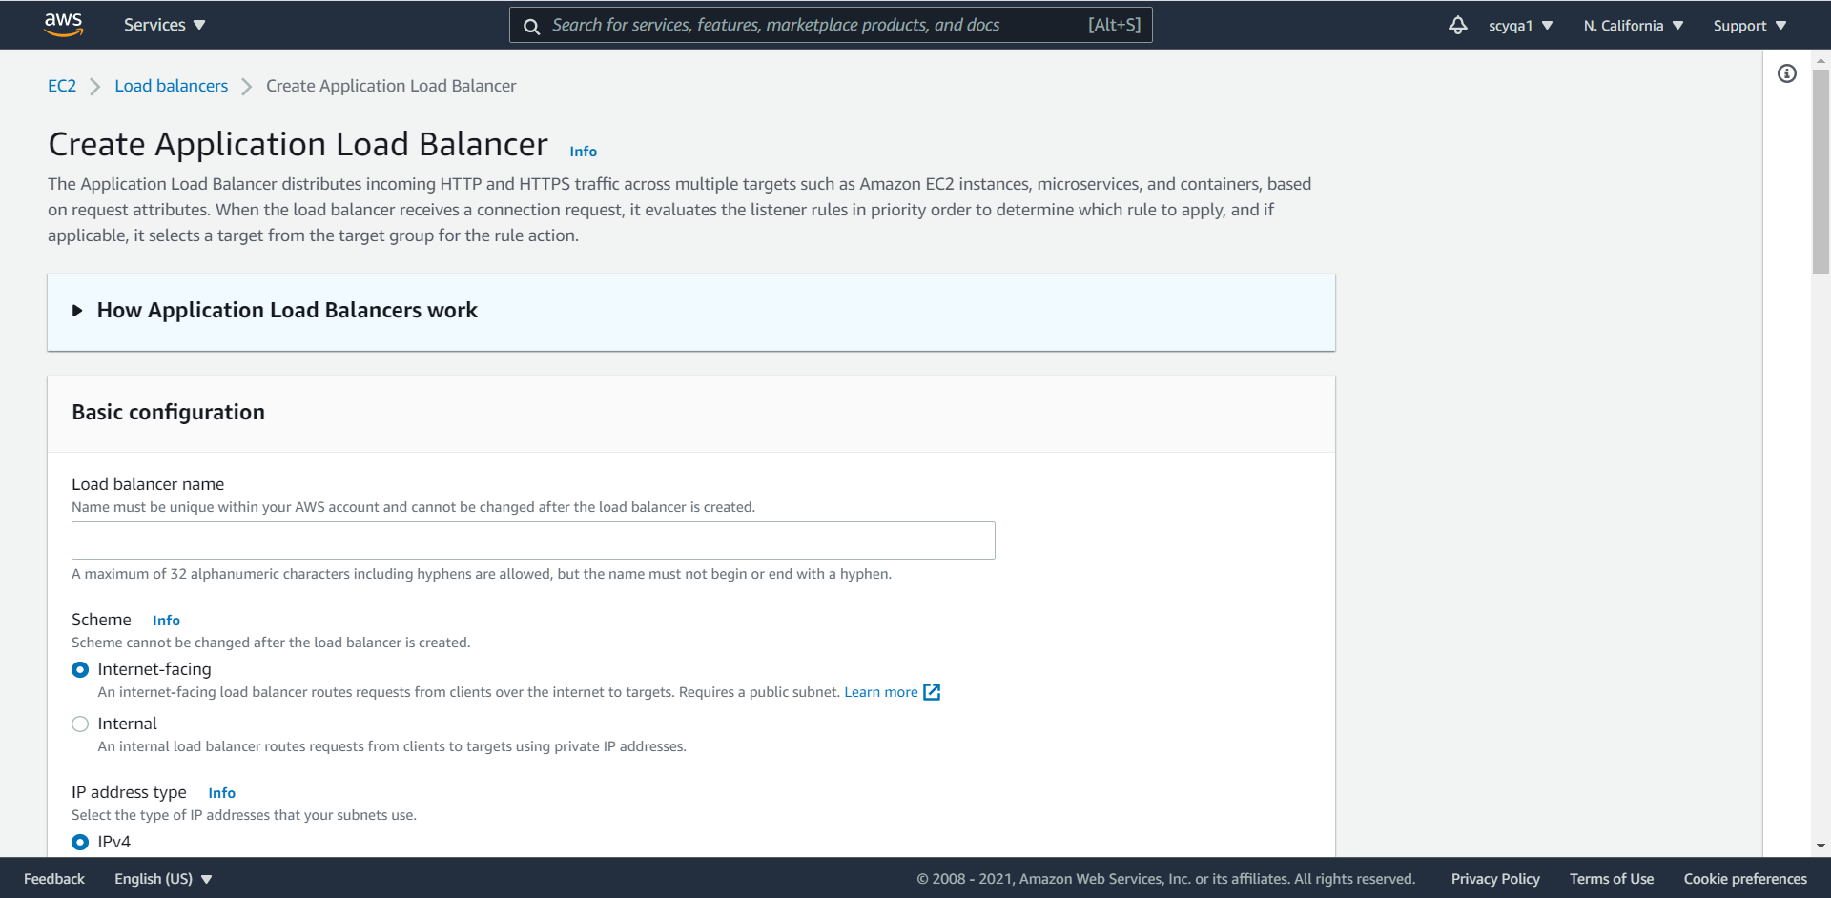

Final result

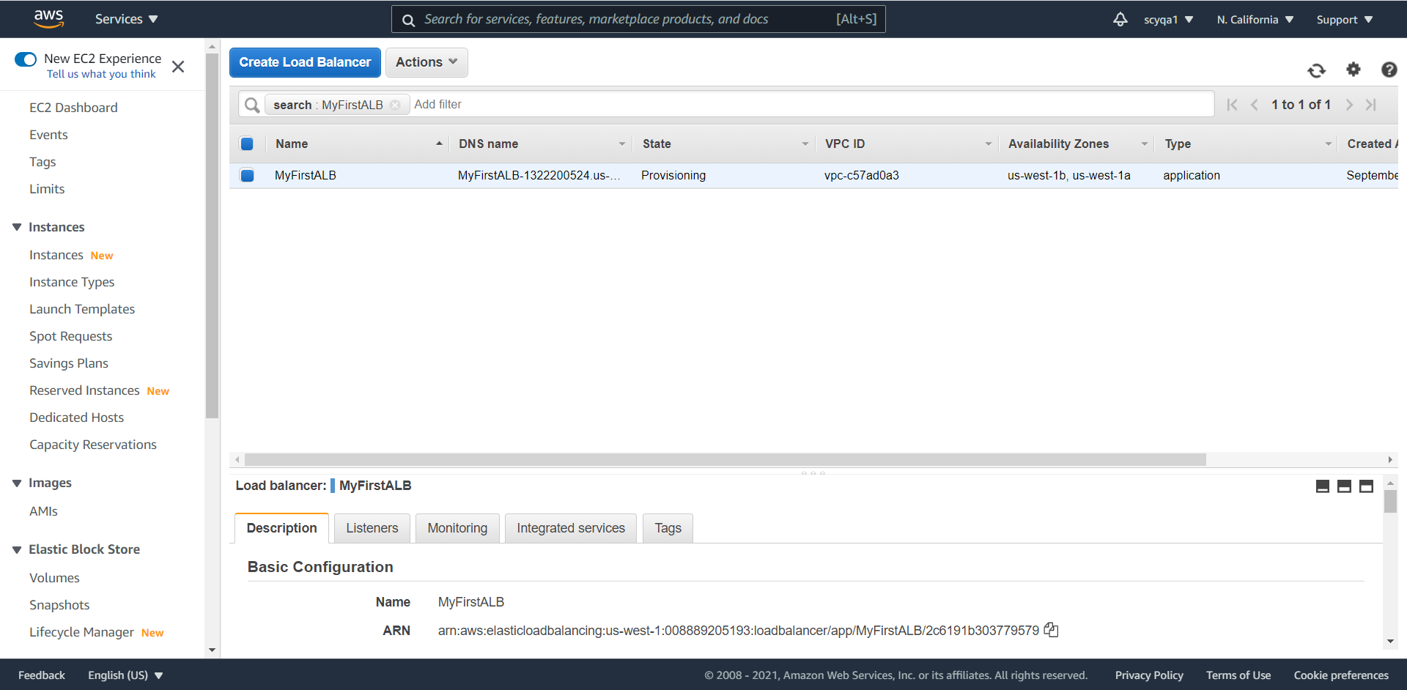

**4)Create a VPC**

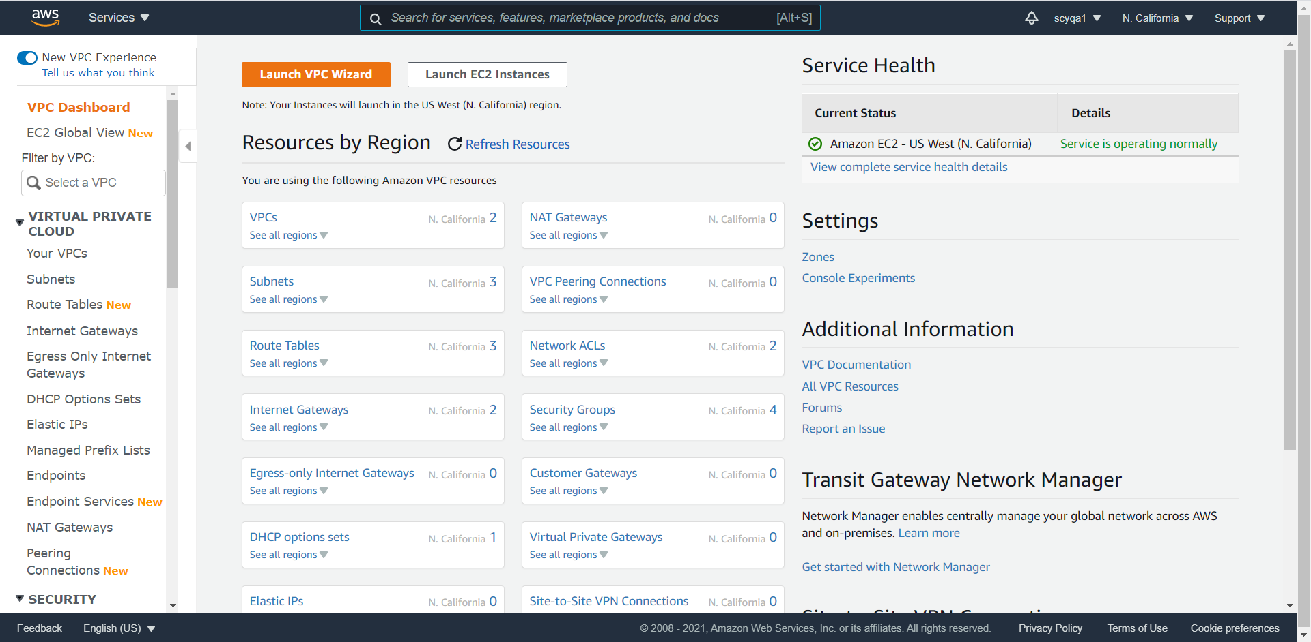

Launch EC2 instances

Step 1: choose AMI

Similarly, I choose Amazon Linux 2 AMI.

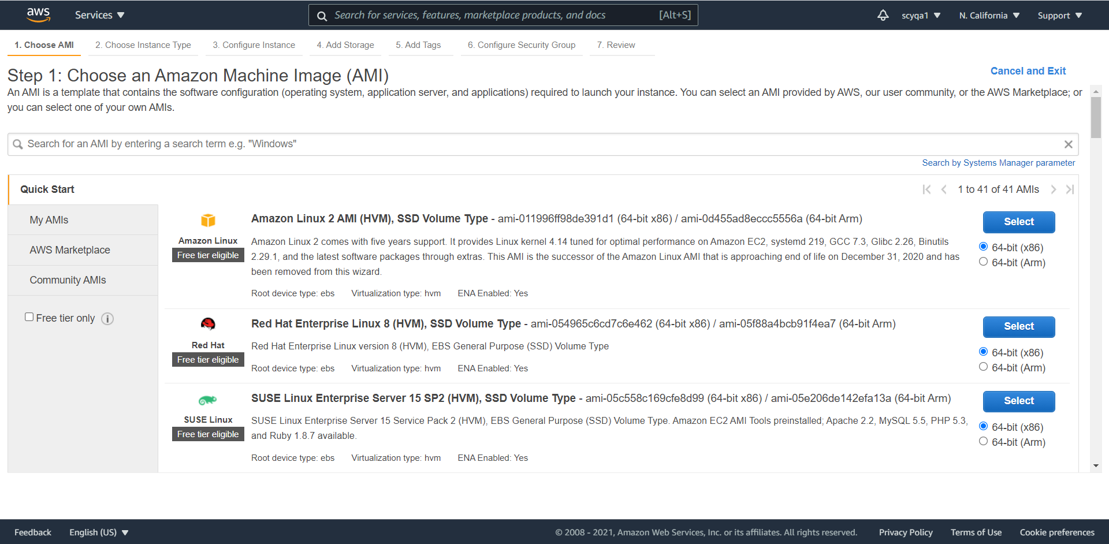

Step 2: choose an instance type

Similarly, I select t2.micro.

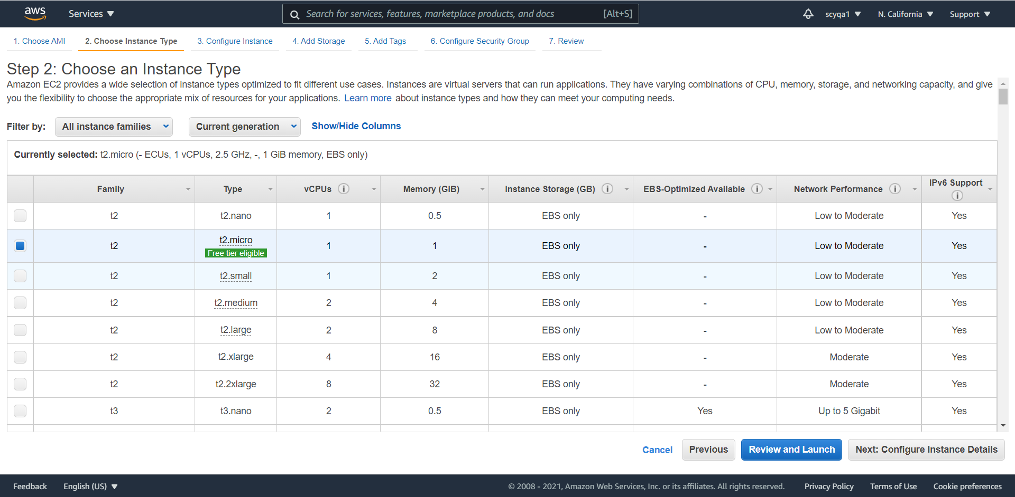

Step 3: configure

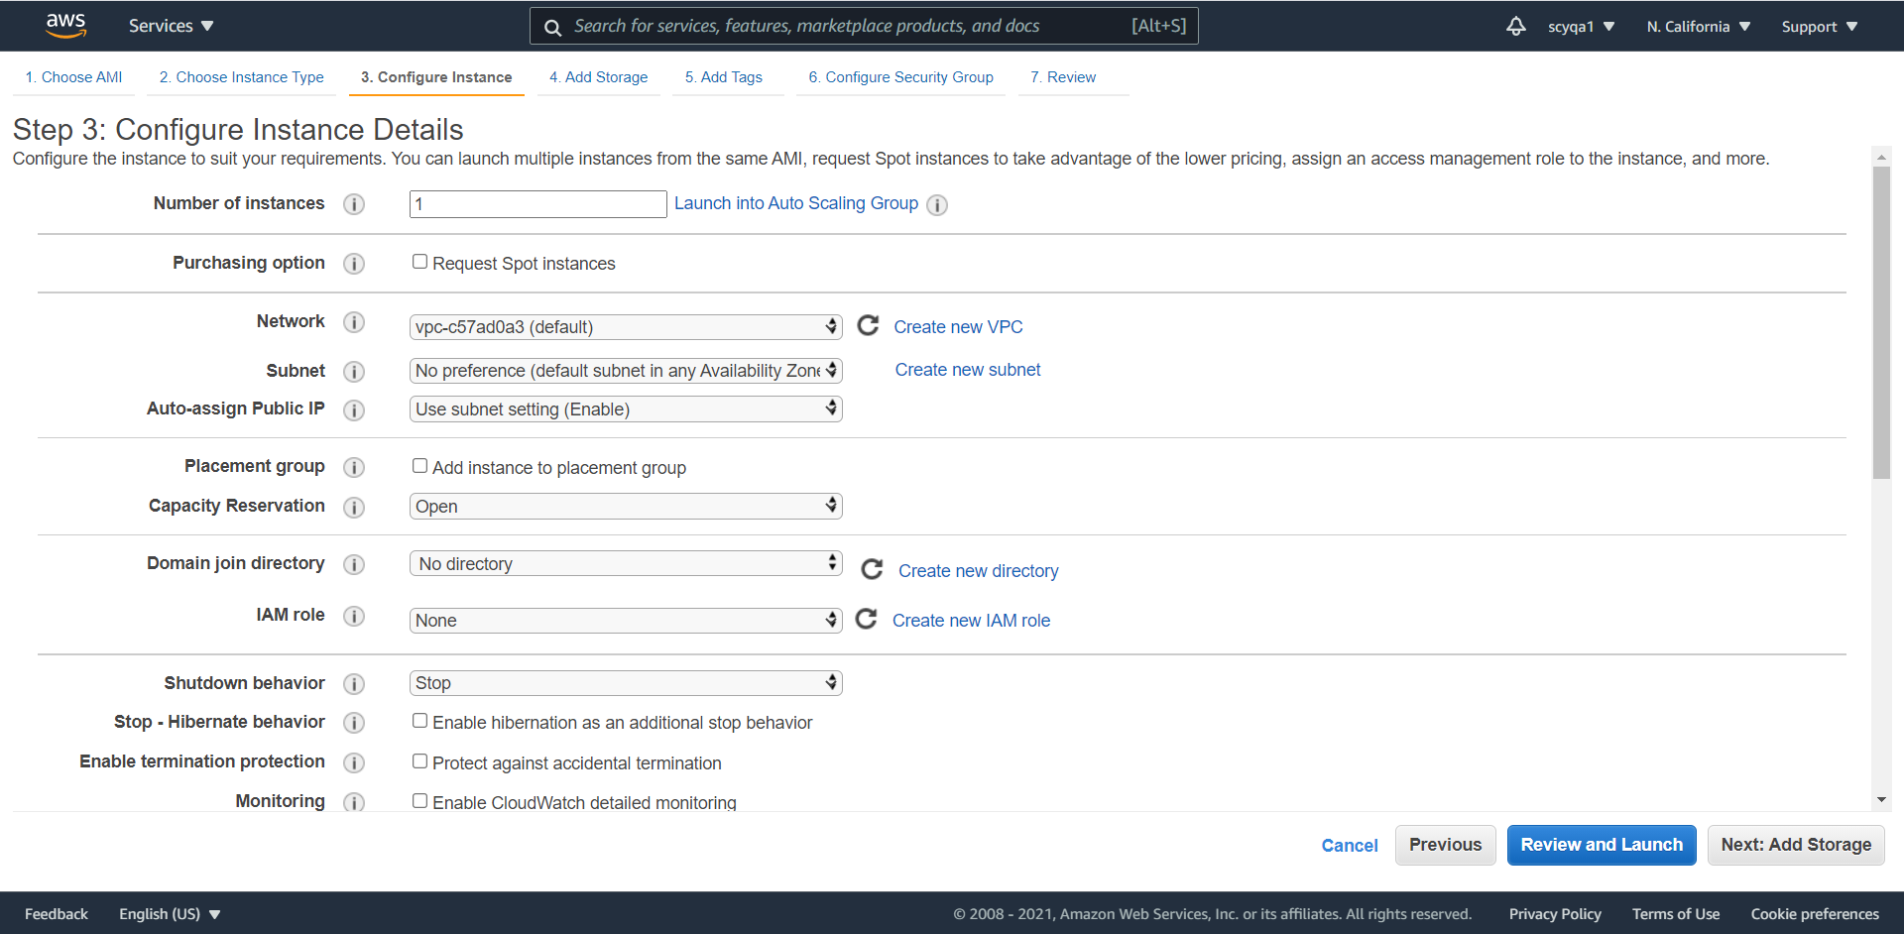

Step 4: add storage

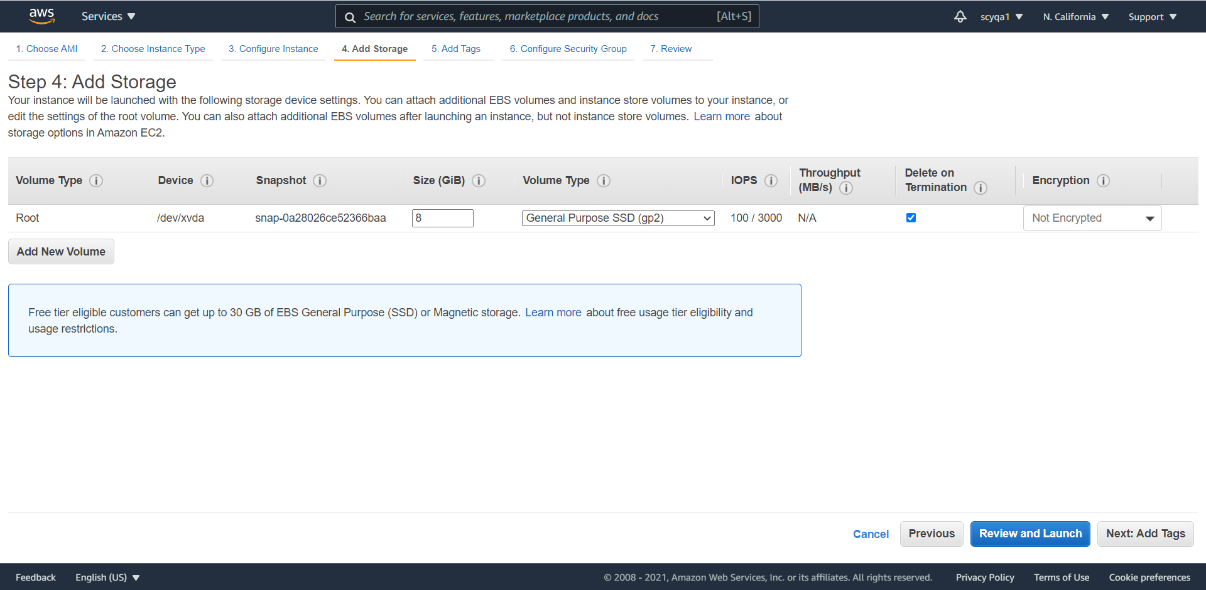

Step 5: add tags

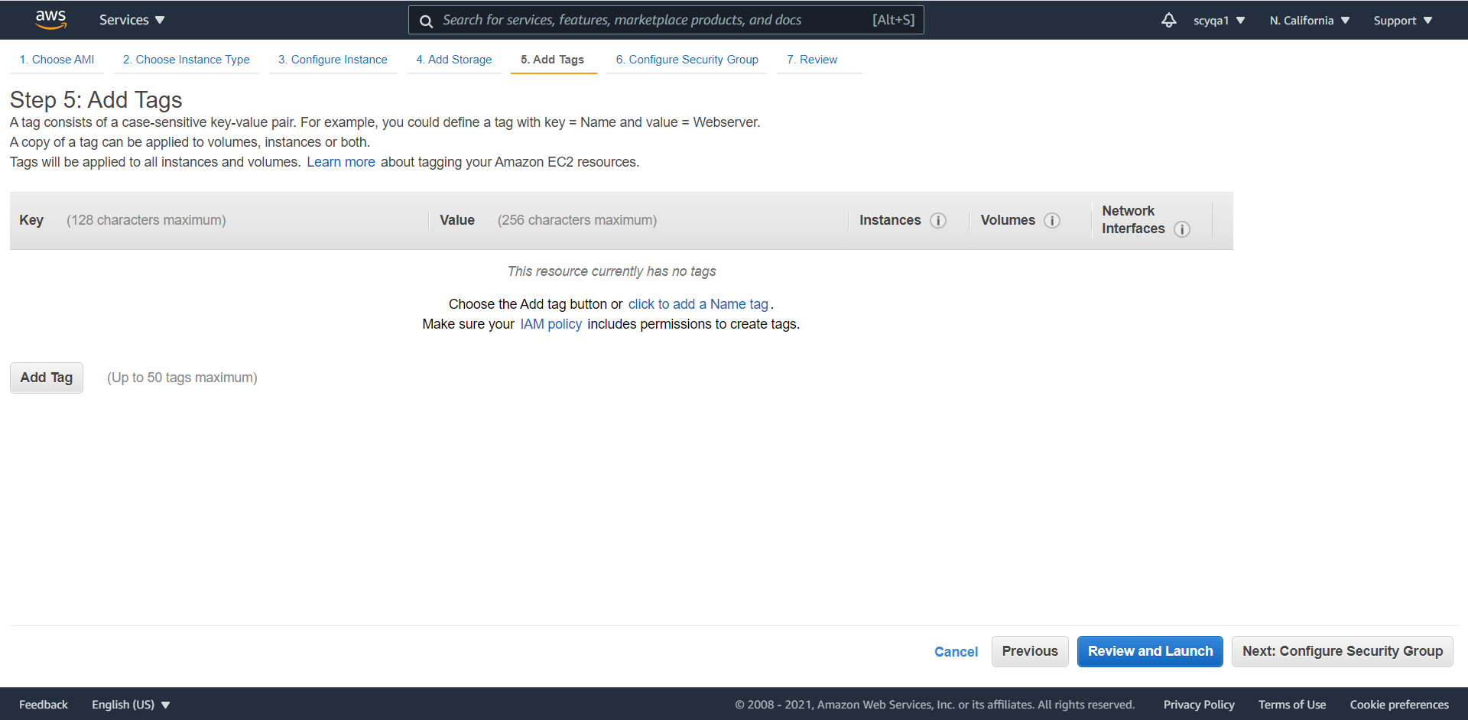

Step 6: configure security group

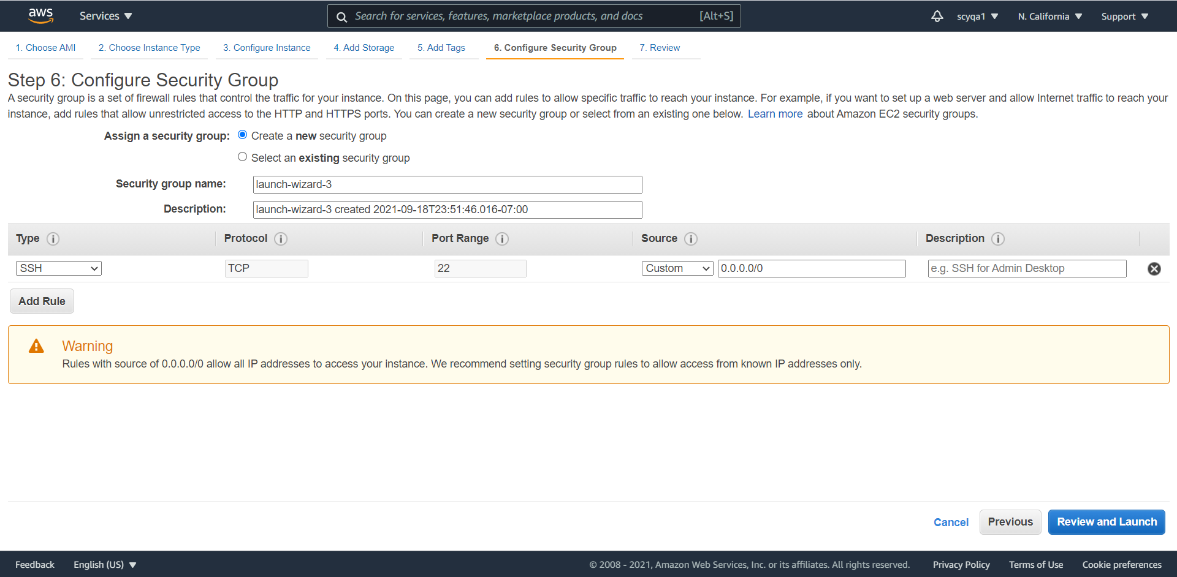

Final result

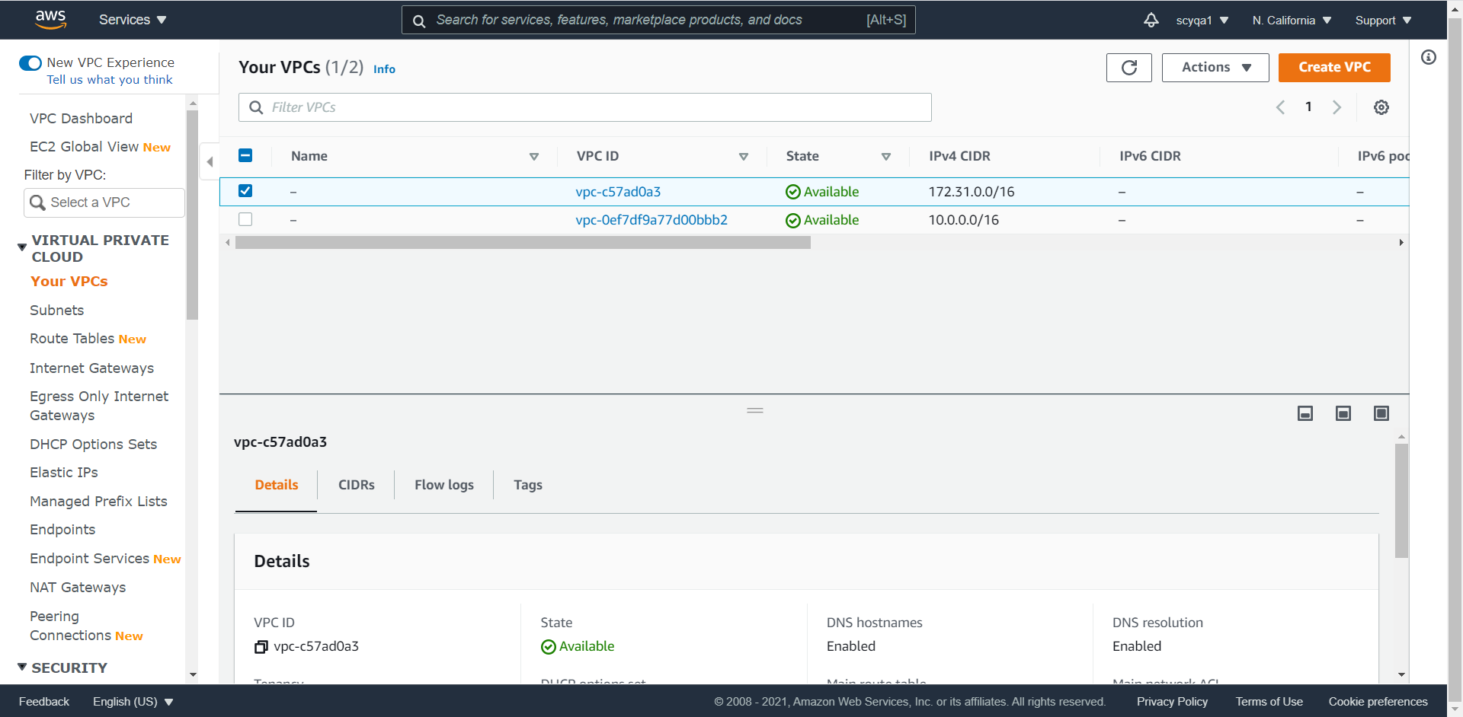

5)Write a ‘hello world program’ in Python using AWS

Create Lambda Function in Python

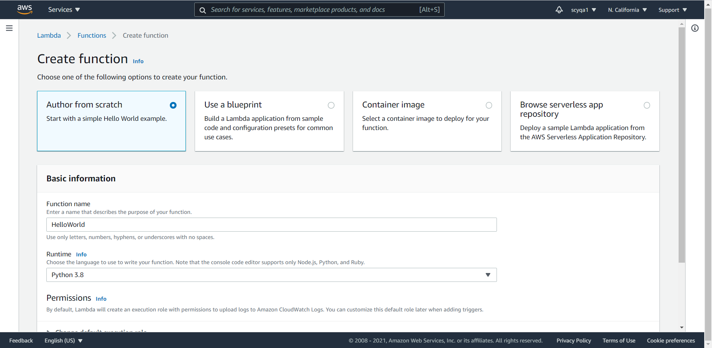

Choose Author from scratch and configure environment of the python 3.8

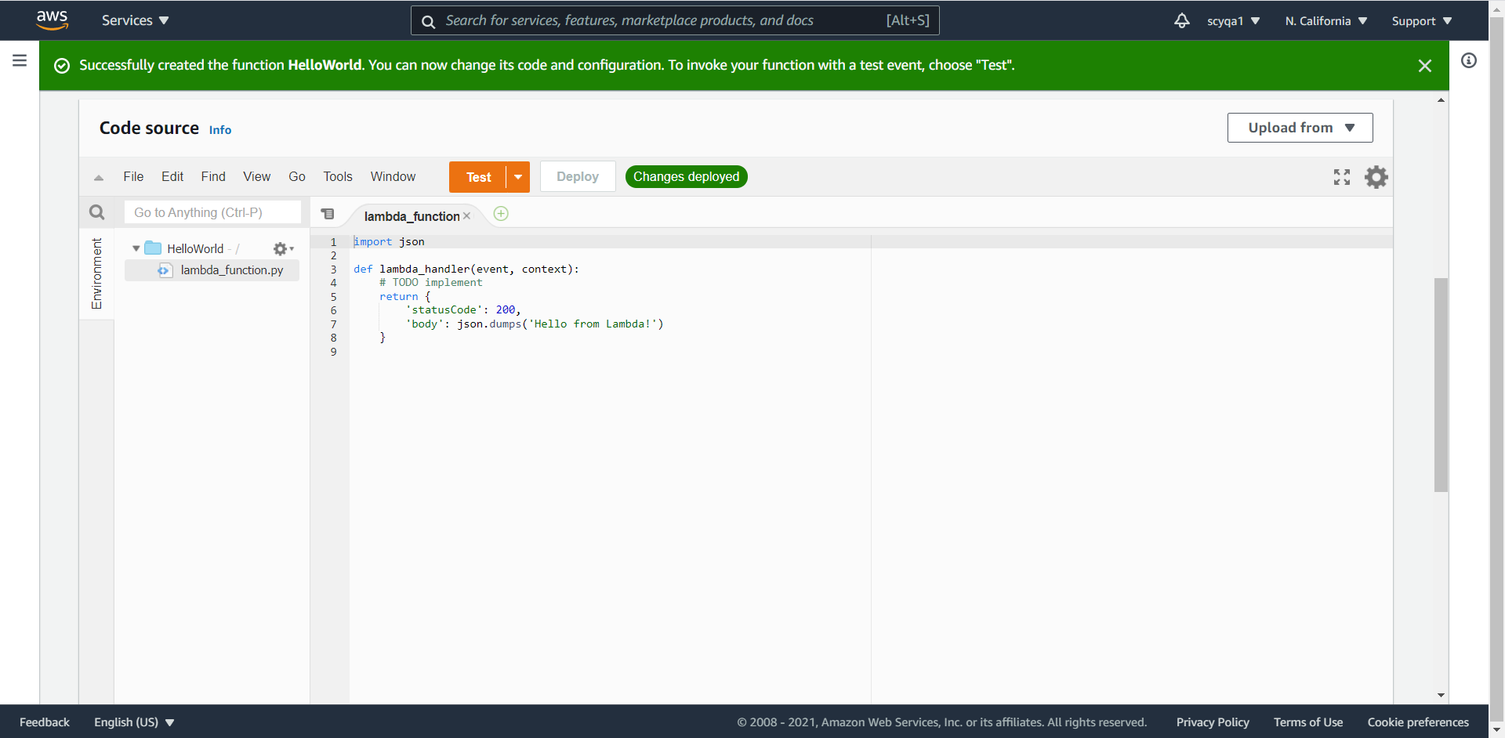

Configurations

I can change the configurations for your Lambda function. For Example, set the request time out and memory.

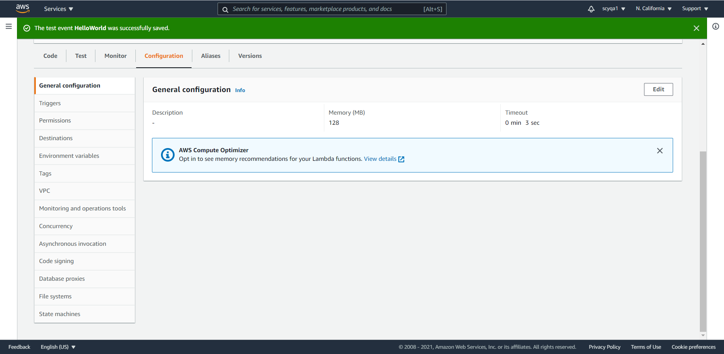

Configure test event

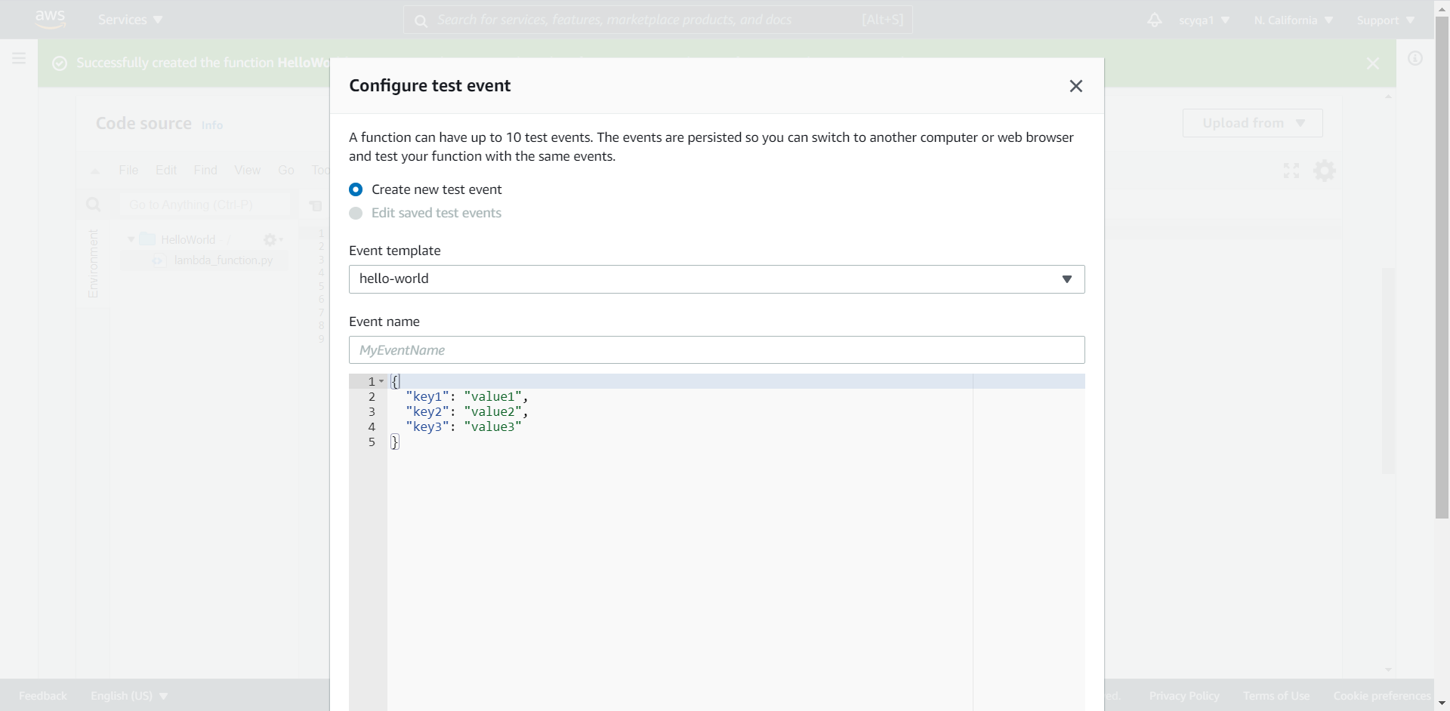

Final Response:

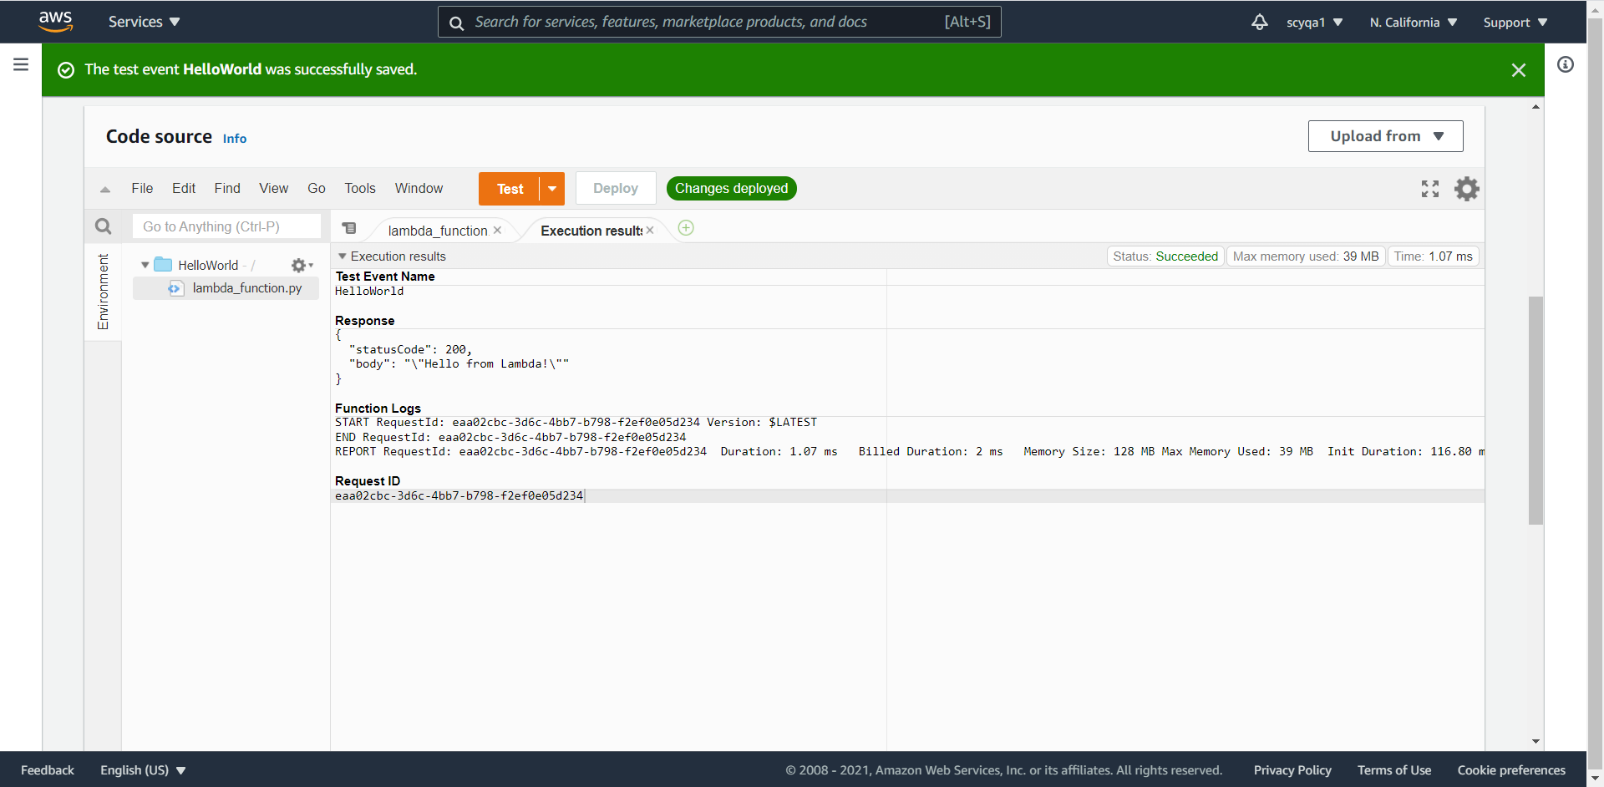

**Summary:**

As an overview of this project, I have to say I put a lot of work into it, especially in the condition we have an assignment and a project in just one week. Through this project, for the part1, I learnt a lot about python coding for amazon web service using the library ‘boto3’. And for the part 2, I reviewed the work of first week, and learnt some techniques about Lambda on AWS. This helps with understanding and long-term memory. More specific details about such as AWS and EC2 VPC will be covered in the next section.

The Amazon Web Services Global Cloud Infrastructure offers cloud computing services globally through its secure, flexible, effective platform. One of the remarkable advantages of the AWS is to lower the cost needed to establish the up-front capital infrastructure, which allows users to spin up numbers of servers instantly. There are also some other benefits by AWS. Firstly, AWS provides a vast global cloud infrastructure for users to make innovations, do experiments and iterate computations quickly. It is easy to build new applications and adapt them to the required scales of the workload. Secondly, AWS provides different use of services such as development platform or programming model for different users, which enables users to choose corresponding modes and experience the flexibility according to their work demand. Moreover, AWS is also a durable and reliable technology with official certifications and audits. In order to guarantee the integrity and safety of user's data, the AWS system is built with multiple layers of operational and physical security.

Through a lot of programming, I understand what the AWS can serve better. For example, the instances, the tags, the operations of reboot, creation, stop, update and so on. Through the comprehensive application of them, I believe, in the future, I can cooperate with team members of the class could computing, my friends or colleagues to complete larger projects in a more efficient way. I'm grateful for the experience